- 5/24/22

Hi, David.

Best wishes for your upcoming work on the JMRL name matter.

For what it’s worth, there is no VPRL among all Virginia public libraries (https://www.lva.virginia.gov/public/libraries_all.asp).

VPRL could stand for Virginia Piedmont Regional Library.

Albemarle County, Charlottesville, Greene, Louisa, and Nelson counties are all part of a Virginia Piedmont map (https://duckduckgo.com/?q=where+is+the+Virginia+Piedmont%3F&hps=1&atb=v35-1&iax=images&ia=images&iai=http%3A%2F%2Fwww.virginiaplaces.org%2Fregions%2Fgraphics%2Fpieddcr.png).

Will be interesting to follow your and the Board’s research and discussions on the JMRL name matter.

Cheers!

ALBEMARLE VIA EMAIL

--

- 5/24/22

message: I heard on the radio this morning the board of directors is considering changing the name of your wonderful library system due to Madison and Jefferson being considered "white supremacists" This is not something serious people would discuss nor is it true nor should you consider it. Please let reason dictate. You have the ability to be serious people--not ridiculous people

VIA WEB CONTACT FORM

--

- 5/24/22

message: Dear JMRL Board: Jefferson and Madison both helped start the process that eventually ended slavery. Can't we at least acknowledge their contributions to that long-range major change? The UN reports that there are at least 24 million actually slaves in the world today. Must we ban the names of all of the countries that harbor slavery? Maybe we should condemn ourselves for buying products made by actual slaves today? Where does it stop in our glass houses?

CHARLOTTESVILLE VIA WEB CONTACT FORM

--

- 5/24/22

message: Dear JMRL Board: Jefferson and Madison both helped start the process that eventually ended slavery. Can't we at least acknowledge their contributions to that long-range major change? The UN reports that there are at least 24 million actually slaves in the world today. Must we ban the names of all of the countries that harbor slavery? Maybe we should condemn ourselves for buying products made by actual slaves today? Where does it stop in our glass houses?

CHARLOTTESVILLE VIA WEB CONTACT FORM

--

- 5/24/22

Hi David,

Been a while, and I hope all is well with you.

I read about the movement to change the library name, and have mixed feelings, but understand. My wife and I discussed possibilities, and I thought honoring an abolitionist from Virginia might be one way to go, and am forwarding an article as perhaps a start to find an appropriate name.

My wife suggested recognizing one of Jefferson’s slaves. E.g. - ISAAC GRANGER JEFFERSON. Isaac Granger Jefferson (1775-1846) was the son of George Granger, Sr., an enslaved foreman of labor and overseer at Monticello, and Ursula, an enslaved pastry cook and laundress. Isaac Jefferson worked at Monticello as a nailmaker, tinsmith, and blacksmith.

Or maybe York. York was an American explorer and historic figure, being the only African American member of the Lewis and Clark Expedition; he participated in the entire exploration and made significant contributions to its success. He was the first African American to cross the continent and see the Pacific

I would be interested in seeing how the naming goes.

Best,

ALBEMARLE VIA EMAIL

--

- 5/24/22

I’m just calling to say how shocked I am, how astonished I am that you would even consider this issue would come up about changing the name of our library given the fact that our Jefferson created with his own library the beginnings of the Library of Congress I mean come on, get real, things are way out of hand when a handful of dissidents can could change the whole name of a library that is an important library an important name very important name about the most important name in libraries in the nation wouldn’t you say considering that in his own personal library was the foundation of our Library of Congress. If you want to talk about it, I doubt if you would, but if you do there is nothing much to say is there. My number is XX my name is XX XX, thank you.

VIA TELEPHONE

--

- 5/24/22

Plunkett. It’s XX. You might be the same fellow that I knew many years ago at the university library when I was working on the Holsinger book and doing local history stuff. I left you a message before about my concern about this name changing thing and then I read the article the whole article and at the end of the article at the Daily Progress there is a woman who is bringing you know who wants to have a name change for the library who is calling our president considered to be one of the smartest men on the planet at the time and maybe forever, Jefferson, a white supremist and I that’s just going to far that is too far it just is taking history out of context and we’ve got to draw the line somewhere especially when it comes to Jefferson and libraries and I know you know what I mean. Thank you goodbye.

VIA TELEPHONE

--

- 5/24/22

Stop trying to rewrite history and leave the library's name alone, find something else to get butt hurt about.

VIA FACEBOOK

--

- 5/24/22

message: David, I think censorship of the name of the library is on a par with book censorship and as such should not be tolerated. That being said,I know you will probably have to cave to “public opinion”. Just wanted to speak up …. as an old hippie and liberal.

LOUISA VIA WEB CONTACT FORM

--

- 5/26/22
Mr. Plunkett,
I am writing to express my opposition to changing the name of the Jefferson Madison Library Board. These men were the Founders of our GREAT nation.
The notion of applying todays “moral standards” to men who lived and died over 200 years ago, is absurd. It’s also disheartening to see a library system consider any action that would erase part of our history. They should be the preserver of historical truth and act independently from the current trend.
You cannot learn of history if you erase it. Please do not change the name to appease someone who is upset with men that are 200 years old. The name James Madison Regional Library is perfect.
LOUISA VIA EMAIL
--
- 5/26/22
Mr. Plunkett,
Why does the Jefferson Madison Regional Library think that eliminating the names of Jefferson and Madison, Founding Fathers of our nation, makes us a better country?
It is necessary to preserve our history to learn from it and not sanitize it to make it nice and not hurt anyone’s feelings!
No one is perfect – not then and not now! No one is “proud” of our slavery heritage, but it did exist and no good will come from erasing it. We should learn from it so that it is never ever adopted again.
Many of our innovations were developed during this dark period – in many cases with owners working with slaves to help each other. During this period even realizing many abuses, many were taken care of and loved by the entire family. Many were provided with an opportunity to read and write, sew, cook, farm, etc. that they never would have learned from their former tribes. Mr. Jefferson sent his chef to Paris to learn new recipes, others in his household designed and hand-crafted chairs and furniture.
Not often mentioned or realized is that they were sold off as slaves by rival tribes. If not sold off, they may have been eaten, beaten, or enslaved in Africa. Again, I say it is important for us to understand exactly what happened and why , and the steps we took to correct this injustice so that it can NEVER happen to anyone again!
I hope this decision is being given careful consideration!
VIA EMAIL
--
- 5/26/22
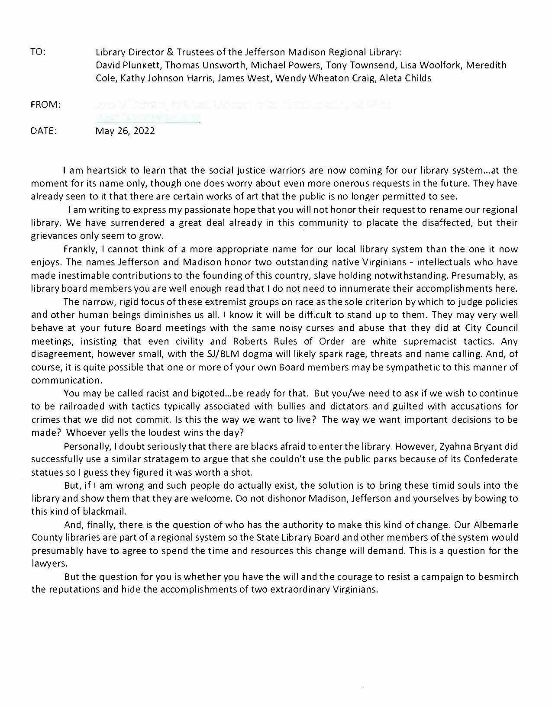
ALBEMARLE VIA USPS
--
- 5/26/22
Dear Mr. Plunkett, I am writing to express my sincere opposition to changing the name of the Jefferson Madison Library. These men were the Founders of our nation and instrumental in the writing of our constitution. The notion of applying todays “moral standards” to men who lived and died over 200 years ago, is absurd. It’s also disheartening to see a library system even remotely consider any action that would erase part of our history. They, of all of our institutions, should be the preserver of historical truth and act independently from the current trend.
VIA EMAIL
--
- 5/27/22
Dear Mr Plunkett:
Please do not change the name of Jefferson Madison Regional Library. Jefferson and Madison were founders of our country. Like all humans, they did both good and bad. America like many nations and civilizations before them practiced slavery which is agreeably an evil practice. Slavery is gone but not forgotten. We should not forget the national mistake of slavery as we should not forget any aspect of our history including the many contributions of Madison and Jefferson. Please find another way to show disapproval of slavery. Suggest expansion of Black history education and accomplishments.
Please do not erase any part of our history. We need to remember the mistakes like slavery so we do not repeat them.
LOUISA VIA EMAIL
--
- 5/27/22
I just wanted to comment on the article about the possible changing of the name of the library, which i think isn’t a very good idea. I’m a daily idea of the library usually at the Gordon Branch which is your old stomping grounds, and occasionally on the weekend at the Central Library but I just think its a foolish idea and I would be against that. Thank you.
VIA TELEPHONE
--
- 5/31/22
Mr. Plunkett,
I am writing to express my opposition to changing the name of the Jefferson Madison Regional Library Board. These men were the Founders of our nation.
The notion of applying todays “moral standards” to men who lived and died over 200 years ago, is absurd. It’s also disheartening to see a library system consider any action that would erase part of our history. They should be the preserver of historical truth and act independently from the current trend.
VIA EMAIL
--
- 5/31/22
Dear Mr. Plunkett:
I have been a resident in JMRL area for over twenty years. During most of that time I homeschooled my children, and regularly used JMRL resources and have had my children participate in library activities, including the summer teen program. In fact, my oldest child just received her masters in library science. Now as an attorney working in the area, I continue to value JMRL resources. Lastly, I am an Air Force veteran who values our American history, especially those who were instrumental in its beginning and foundation of the government. In sum, I have had great respect for the library and its resources.
It is unfathomable to me that the library system that I have supported for so long would remove former American Presidents' names, including one that was the father of our constitution and one who authored documents underlying the country's ideals (even if they were not necessarily perfect in following them). I understand that somebody is voicing their opinion that the names need removal because they are "offended' because Jefferson and Madison owned slaves. This fact must not be viewed in isolation. You must also realize how you are offending those who value these individuals for the enormous input they had into the strength of our American government and ideals. It does not mean that you do not recognize their flaws. You could find that in any former government official. Additionally, Jefferson and Madison MUST be seen differently thatn those like Lee and and others involved in the civil war confederacy who participated/led a war to destroy the country. Even though flawed, Jefferson and Madison worked to build up our country and to establish ideals so that future citizens and leaders can work to make this a more perfect union. You know that Jefferson was very troubled by slavery but felt constrained by the times to make any significant changes. He wrote the Declaration of Independence which would establish a country which granted more rights than any other on the planet at the time. Jefferson added to our country with the Louisiana purchase and many more actions.
No doubt James Madison's actions on slavery were mixed:
https://encyclopediavirginia.org/entries/madison-james-and-slavery/
"Over a long public career that included a leading role in the federal Constitutional Convention of 1787 and two terms as president of the United States (1809–1817), James Madison, a Virginian who owned enslaved people, compiled a record on the issue of slavery that was mixed at best. Madison supported legislation allowing those who claimed people as property to free their workers without the approval of state or local authorities, but he never liberated his own enslaved workers. Madison opposed the African slave trade throughout his career, yet late in life he defended the westward expansion of slavery. He regularly attacked slavery as a violation of republican principles, without ever putting forward a realistic program to eradicate the institution. Instead, he embraced an unworkable plan to colonize freed enslaved people in Africa. Political realities, economic self-interest, a desire to avoid an issue that could split the Union, and an unwavering conviction that, largely because of white prejudices, whites and free Blacks could not peacefully coexist led Madison to routinely compromise his antislavery convictions."
Are we a perfect union now that we can really allow such attacks against amazing individuals and founding fathers of our nation? They built a great nation, although not perfect. It is especially critical that a library which sits in President Jefferson's home at Monticello not take this stand. Jefferson started and built UVA into one of the most renouned universities in the world. Jefferson wrote the first religious freedom stattue for a state in the colonies. Just up the road sits Montpelier, James Madison's home too, where studies and education on the constitution continue and includes slavery aspects.
If you remove both of their names, you are spitting in their faces and their value in the 'BUILDING" up this country. Removal is not only offensive but will contribute to the destruction of our country as hatred fuels hatred. Many of these groups want total destruction and reestablishment of our government and structure merely based on slavery. No doubt slavery is a blight on our nation's past but it must not be used to eliminate the enormous good that has been done by these individuals and many others. The same ideals that set up the nation led to advancement of changes in civil rights ultimately leading to the end of slavery and rights for women and individuals of color. Removal speaks a thousand words. Why would you want to help censor the past to only include the bad? We must learn from the wrongs in our past, not destroy the good. In other words, you do not throw the baby out with the bath water.
In sum, if the name is changed, many more will be offended every time they see the new name because they will understand why the action was taken. Thus, judge wisely and deny this action for right reasons, instead of just trying to placate one political group.
LOUISA VIA EMAIL
--
- 5/31/22
message: Dear Ms. Craig, My name is XX and I live near Zion Crossroads. I returned from visiting family over the holiday to hear that the board will consider changing the name of Jefferson-Madison Regional Library system. I wanted to ask you, my representative on the board, a few questions: 1. What prompted this request? 2. Why now? 3. What is your opinion? Thank you for your service.
LOUISA VIA WEB CONTACT FORM

--

- 6/1/22

message: DO NOT CHANGE THE NAME OF THE LIBRARY! That's like throwing the baby out with the bathwater. We owe Jefferson for the Declaration of Independence and Madison for the Bill of Rights. Do we want to throw these things out too?

VIA WEB CONTACT FORM

--

- 6/3/22

Please do not change the name of the library.

According to the US census bureau 2021 Albemarle County is 9.7% black.

Changing the name of the library is an effort by a small minority to
change and erase history.

A library should embrace and teach history, not attempt to erase it.

Don't act like the Taliban!

ALBEMARLE VIA EMAIL

--

- 6/4/22

June 4, 2022

David Plunkett - Library Director
Jefferson Madison Region Library

Louisa County has worked hard to support the Jefferson Madison Region Library and to help it grow to become a vibrant part of the community. Unfortunately, the library is being attacked by misguided activists attempting to vilify presidents Jefferson and Madison - nearly 200 years after their death. Those attacks are based on conspiracy theories and meritless allegations.

Thomas Jefferson was the principal author of the Declaration of Independence and was elected the third president of the United States. James Madison is known as the Father of the United States Constitution because of his pivotal role in its development and ratification. James Madison was elected fourth president of the U.S.

Today, there are many towns, cities, businesses, and organizations (including libraries) throughout the United States proudly named after president Jefferson.

Now, a small group claiming to be “descendants of enslaved laborers” is seeking to strip away the names of Jefferson and Madison from our library’s name – seemingly because they deem the names to be offensive to them. The fact that the library’s board of directors would even consider making this change is appalling

The historical achievements of presidents Jefferson and Madison should be celebrated, not censored by the library board of directors.

LOUISA VIA EMAIL
--
- 6/5/22
Dear Mr. Plunkett
Considering the names on the Regional Library are those of two Founding Fathers I urge you to plead to keep the name Jefferson- Madison. It would be hard to find two better names. Also, if there were no names it diminishes our culture and what we stand for. These two men were not perfect but Jefferson did contribute his library to Washington, DC to begin the Library of Congress. These two men lived in our area. Benjamin Franklin as an early supporter of public libraries would be a good name but he lived in Philadelphia.
You are free to share my name and views,
VIA EMAIL
--
- 6/6/22
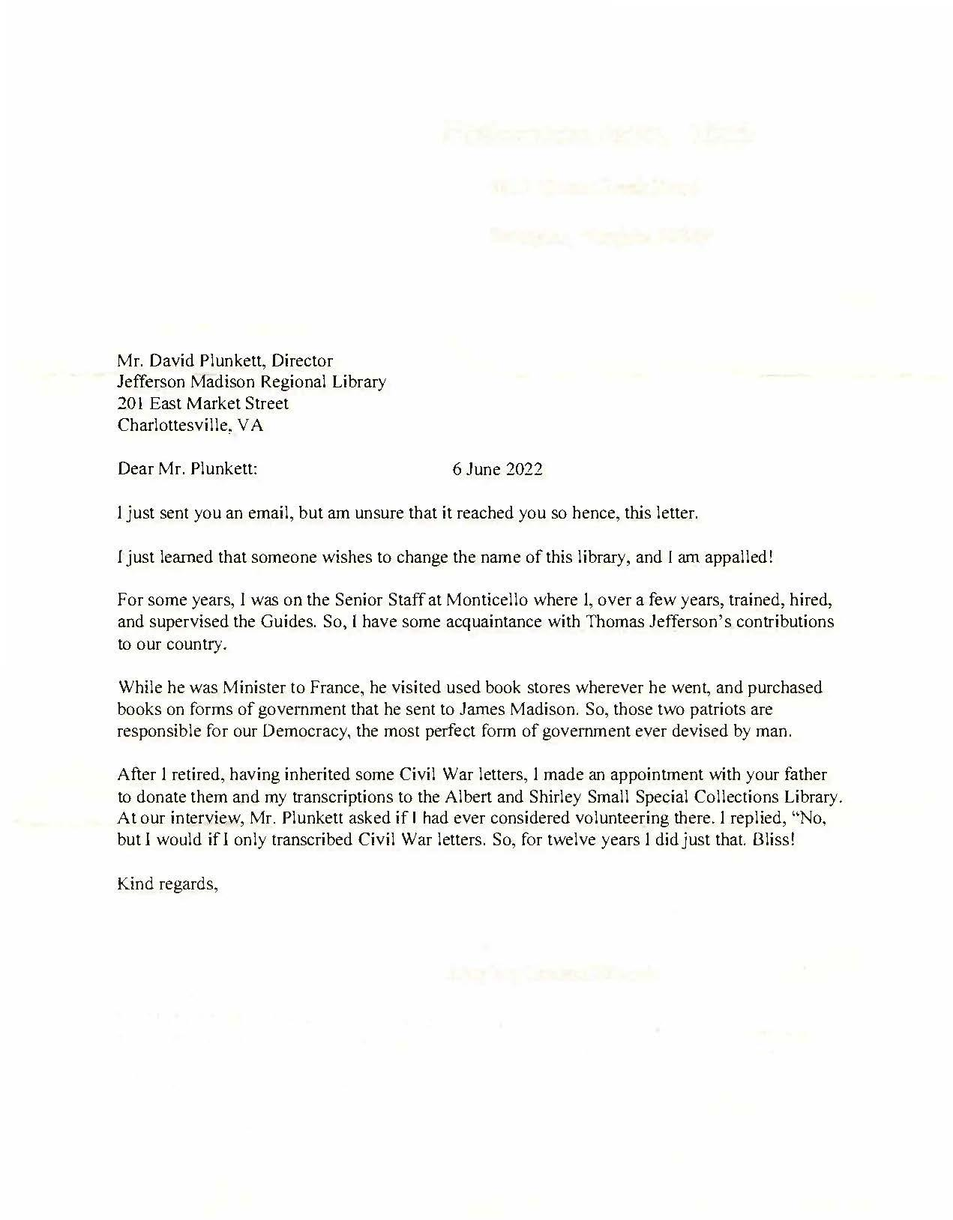
VIA USPS
--
- 6/6/22
Dear Mr. Plunkett,
Please do not allow a name change for the Jefferson-Madison Regional Library. People need to know history more and no one is perfect. Jefferson and Madison did so much for this country and our freedoms and I understand that Jefferson’s library was contributed to Washington, D.C. to begin The Library of Congress. I fully support Lousia County Supervisors defunding the library if the name is changed.
If we don’t study and know our history we will repeat wrongs of the past and cannot continue to become and move toward a more perfect nation.
Thank you for your consideration,
LOUISA VIA EMAIL
--
- 6/6/22
I’m a longtime library user been enjoying the Jefferson Madison Regional Library for long time but I was very disappointed when I saw an article in the paper where the library is thinking of changing the name of the library. I really hope y’all don’t do this. These men Thomas Jefferson James Madison founders of our country US presidents we shouldn’t they certainly deserve to have their name on the library system and I hope that you will not change that. This area has been built on that built on the tourism with Thomas Jefferson and James Madison and I don’t think that we should be ashamed of it in any sense of the word. I just hope that y’all do not change the name it’s a perfectly wonderful name that the people who live in this area can be proud that this area was where US presidents lived. Thank you very much.
VIA TELEPHONE
--
- 6/6/22
message: Dear Mr. Plunkett, I have heard that the Jefferson Madison Regional Library may change its name. I consider this an attack on our history and our great founding fathers. Please oppose this move whole heartedly. We cannot allow for our history to be destroyed.
ALBEMARLE VIA WEB CONTACT FORM
--
- 6/7/22
Hello everyone,
I feel that the Jefferson Madison Regional Library should keep its name. There is no question that Jefferson and Madison were holders of enslaved people, and there is no question that that was a terrible sin with consequences enduring to this day. However, the reason that these Americans were vitally important to America had to do with their novel and enduring contributions to America. They weren't just any plantation owners who owned enslaved people: they advanced democracy. And for that we can and should remember their names, flawed as they were.
VIA EMAIL
--
- 6/8/22
A client has asked me forward the attached memorandum to you. The client does not have the computer capacity to send the exhibits as a pdf file. Mr. Plunkett: after reviewing the memorandum and exhibits, kindly forward same to Library Board of Trustees.
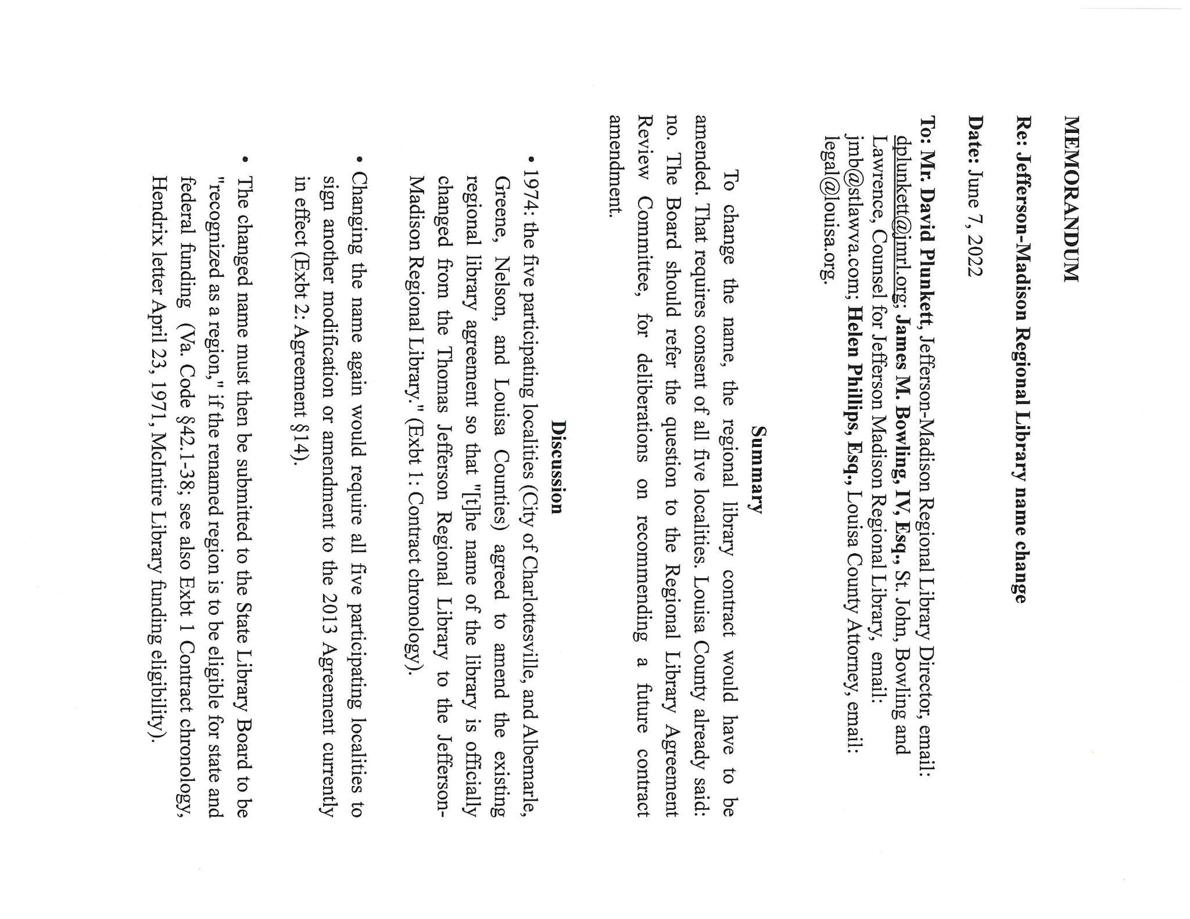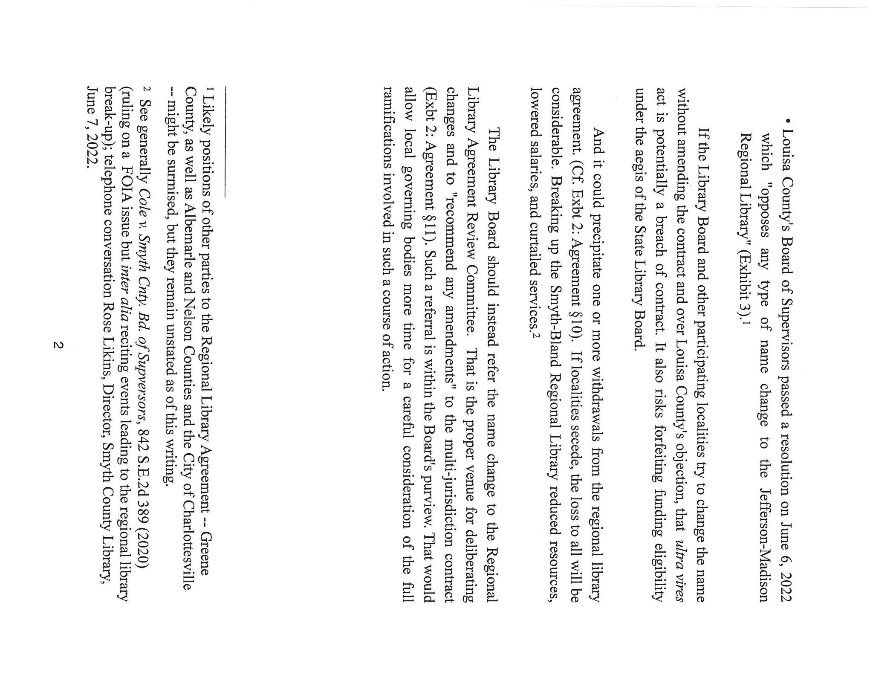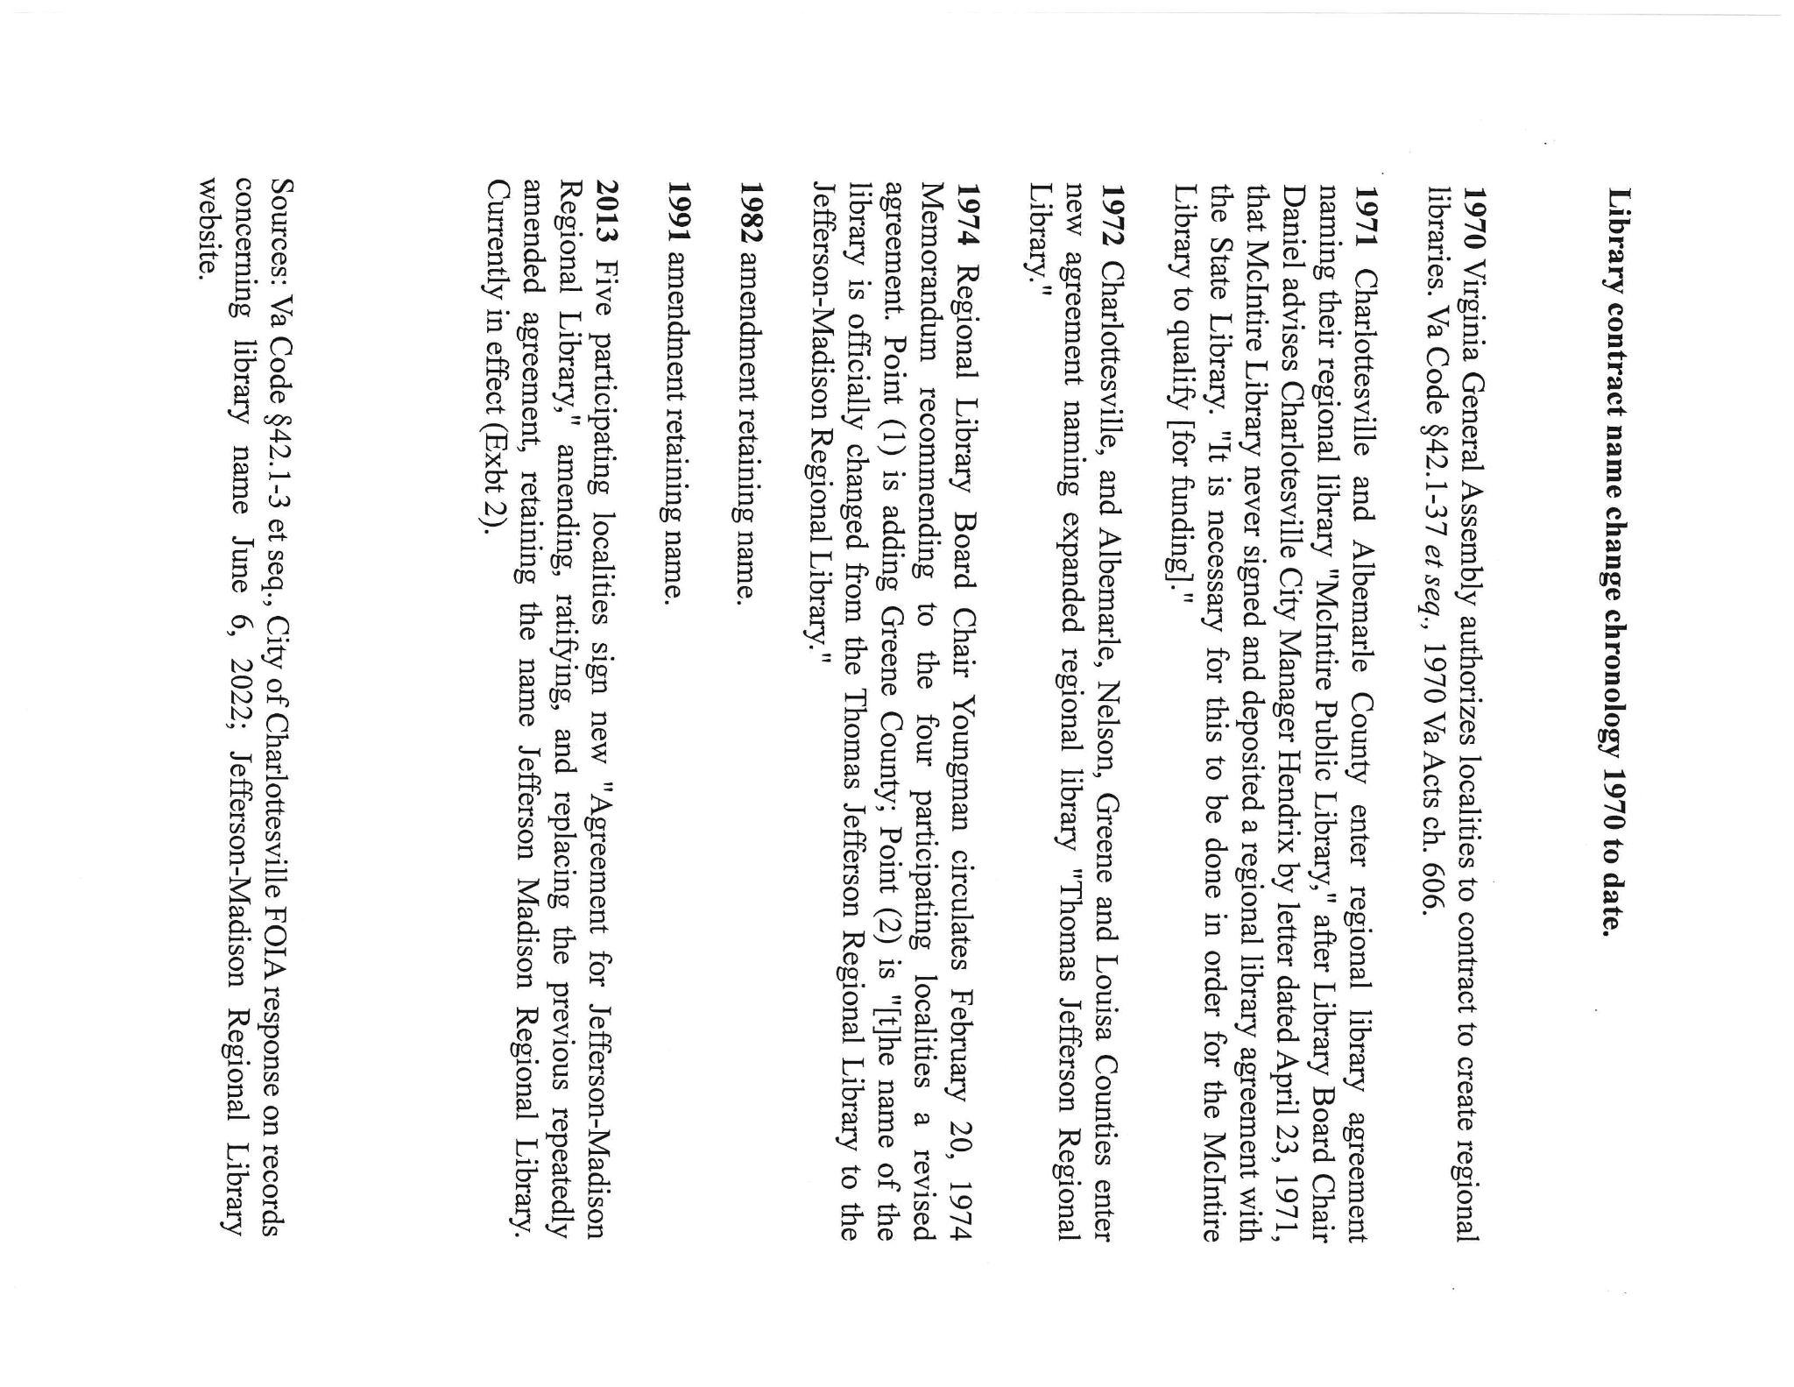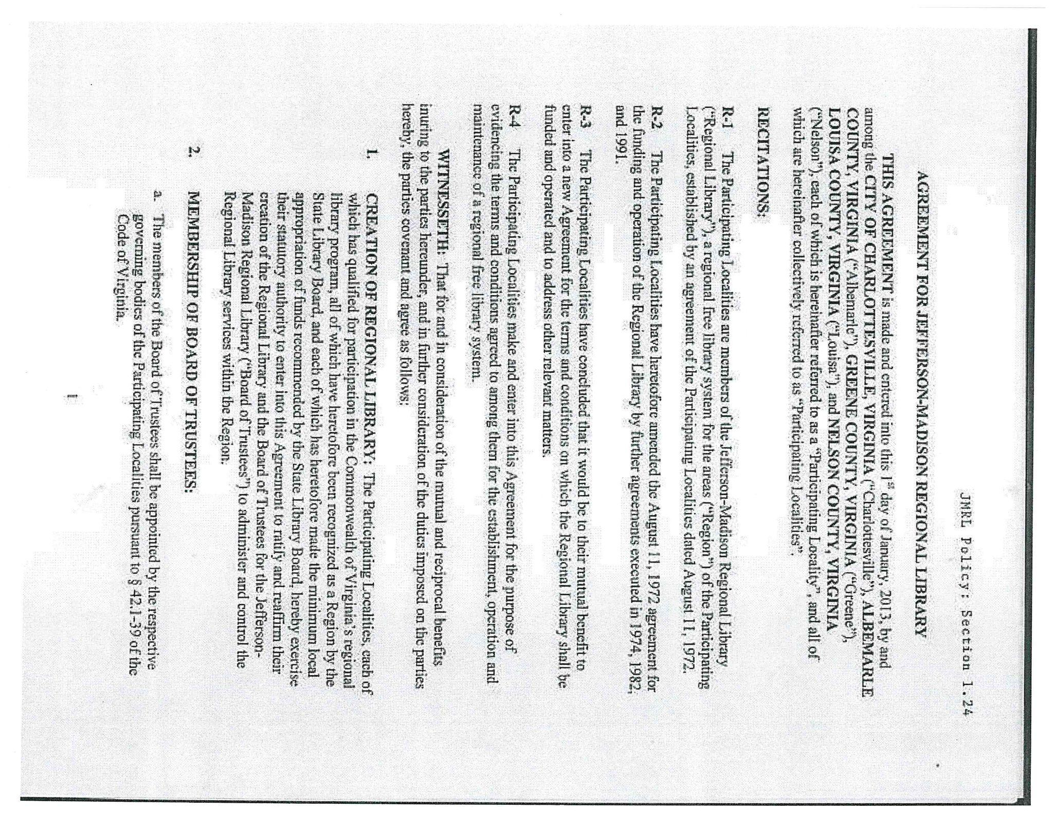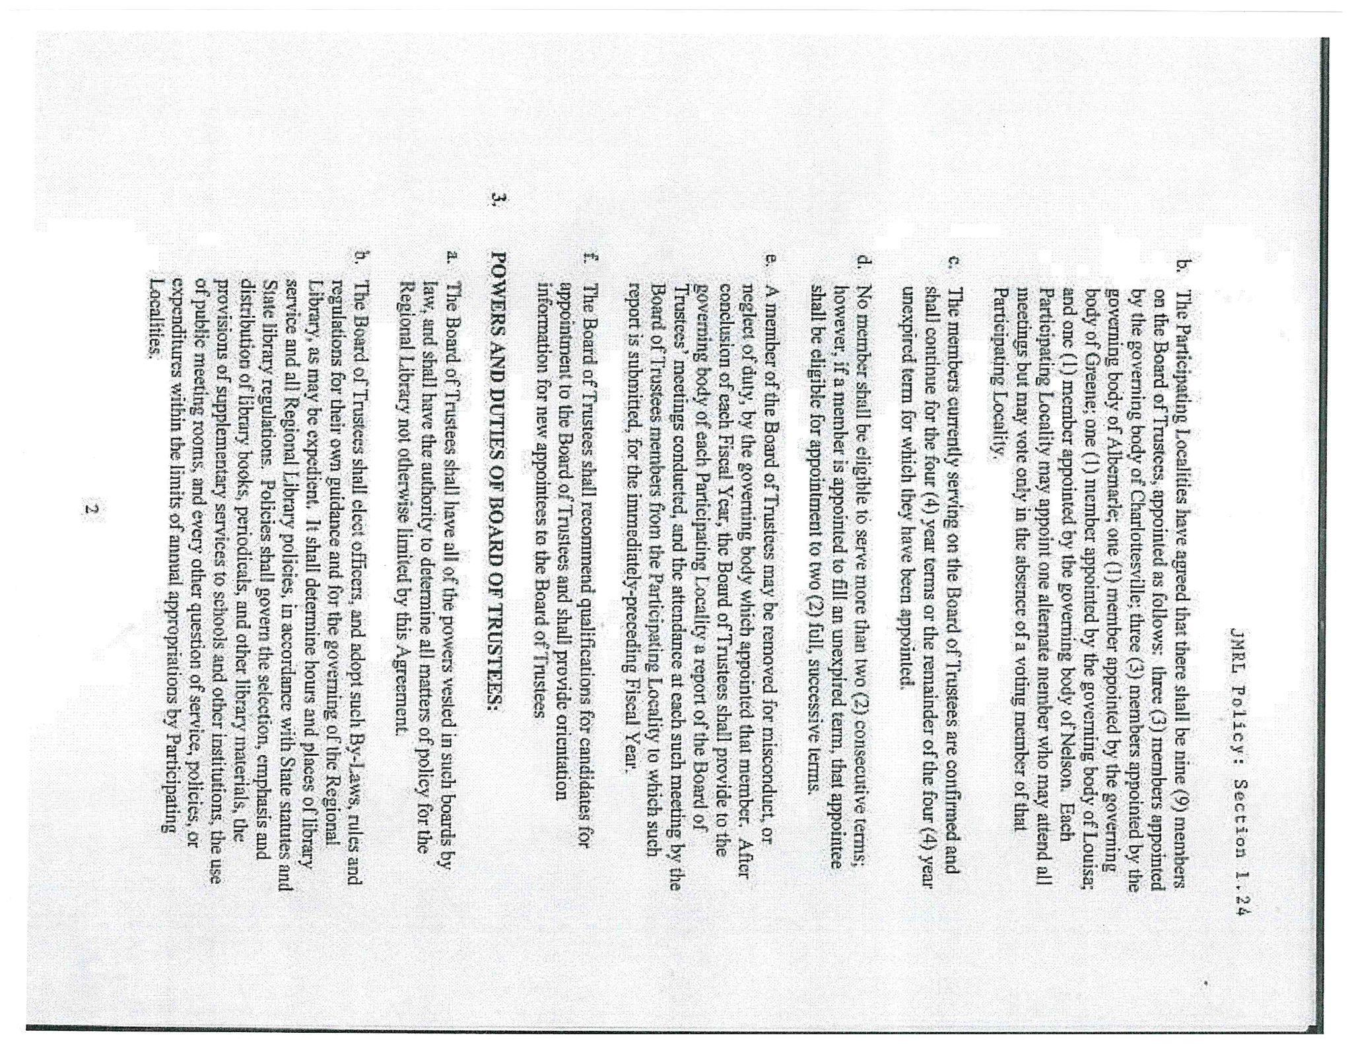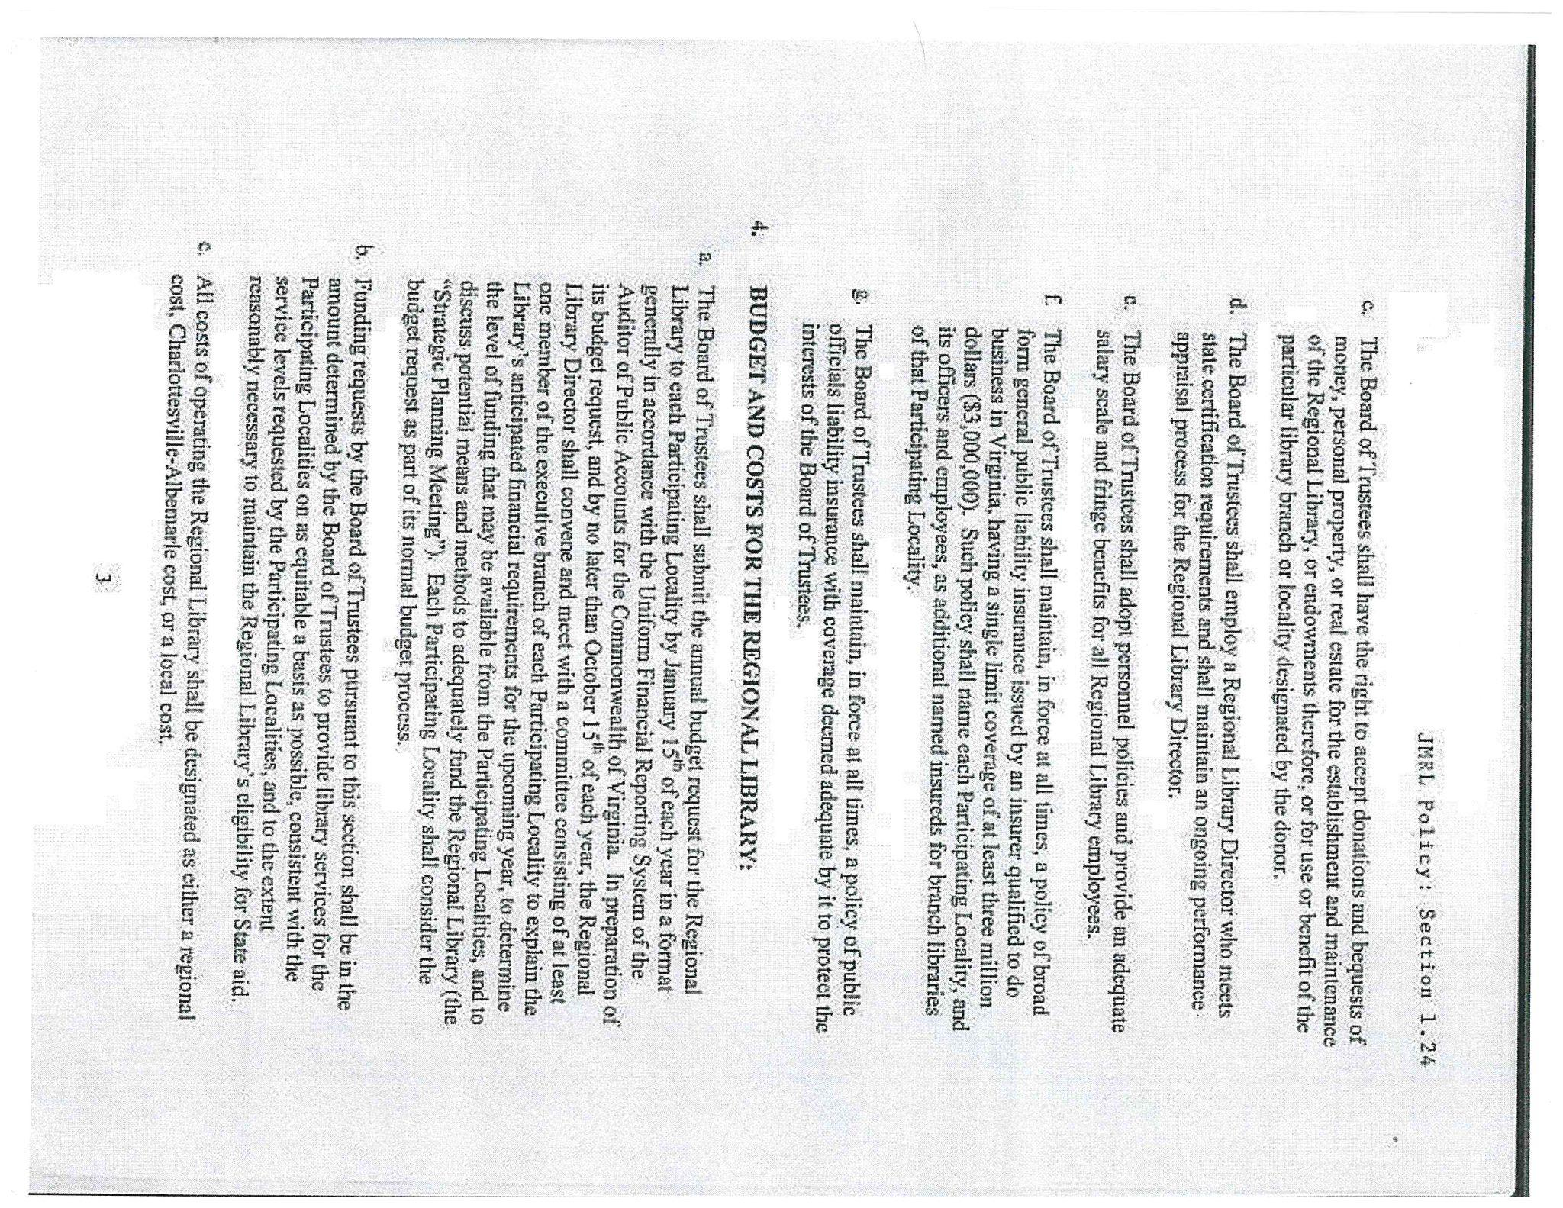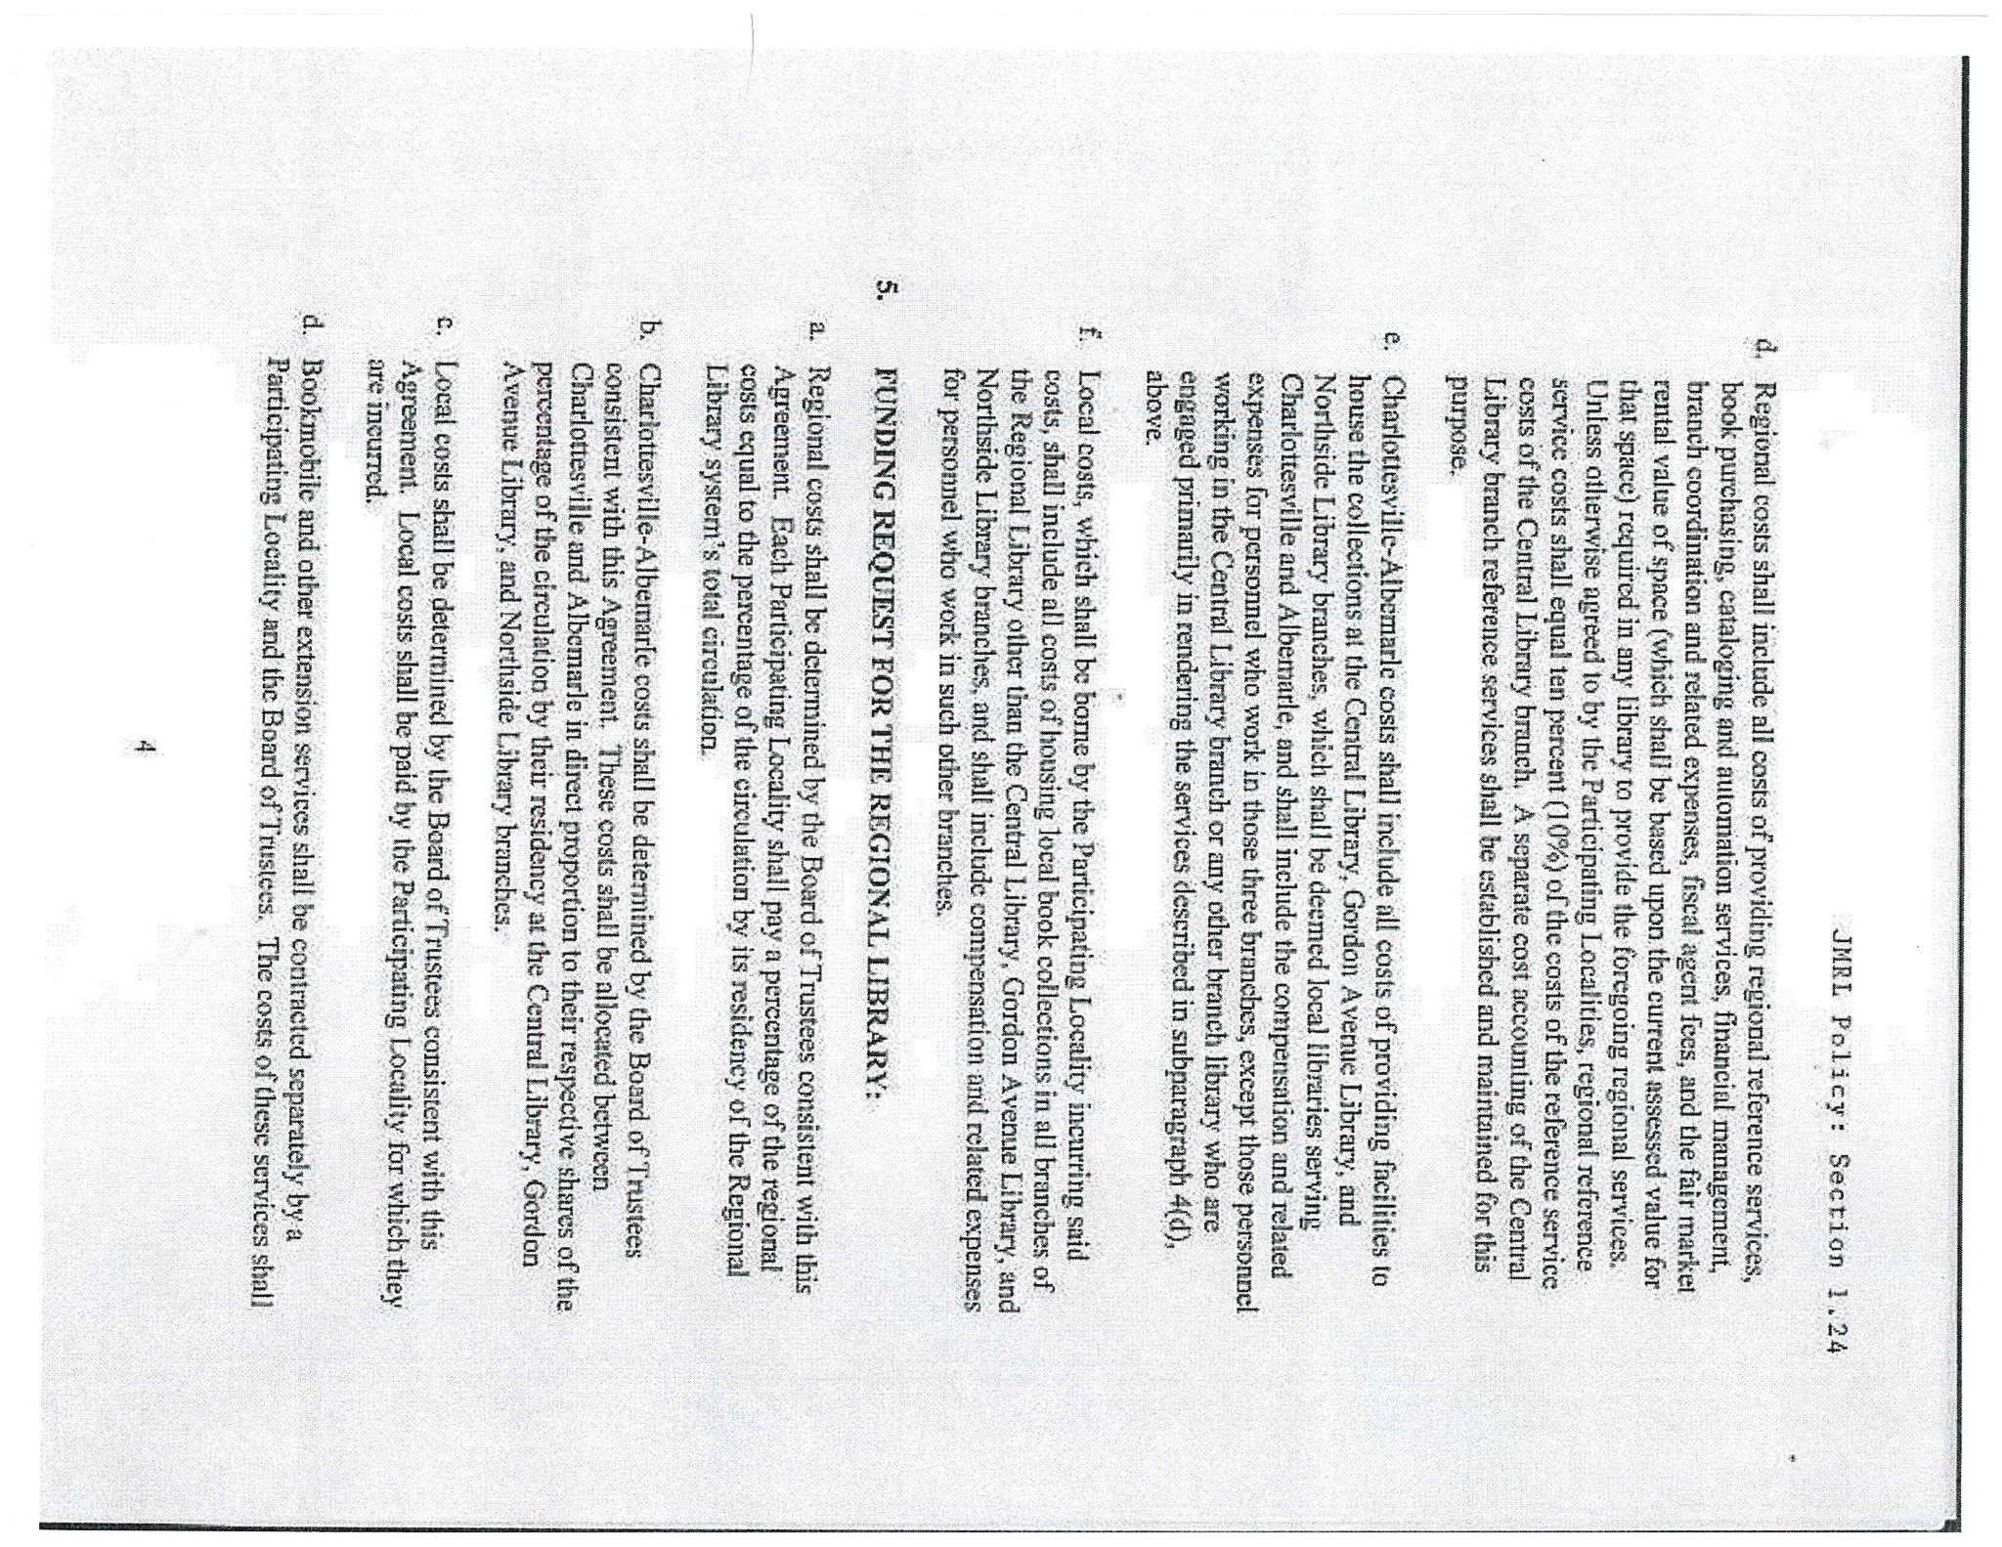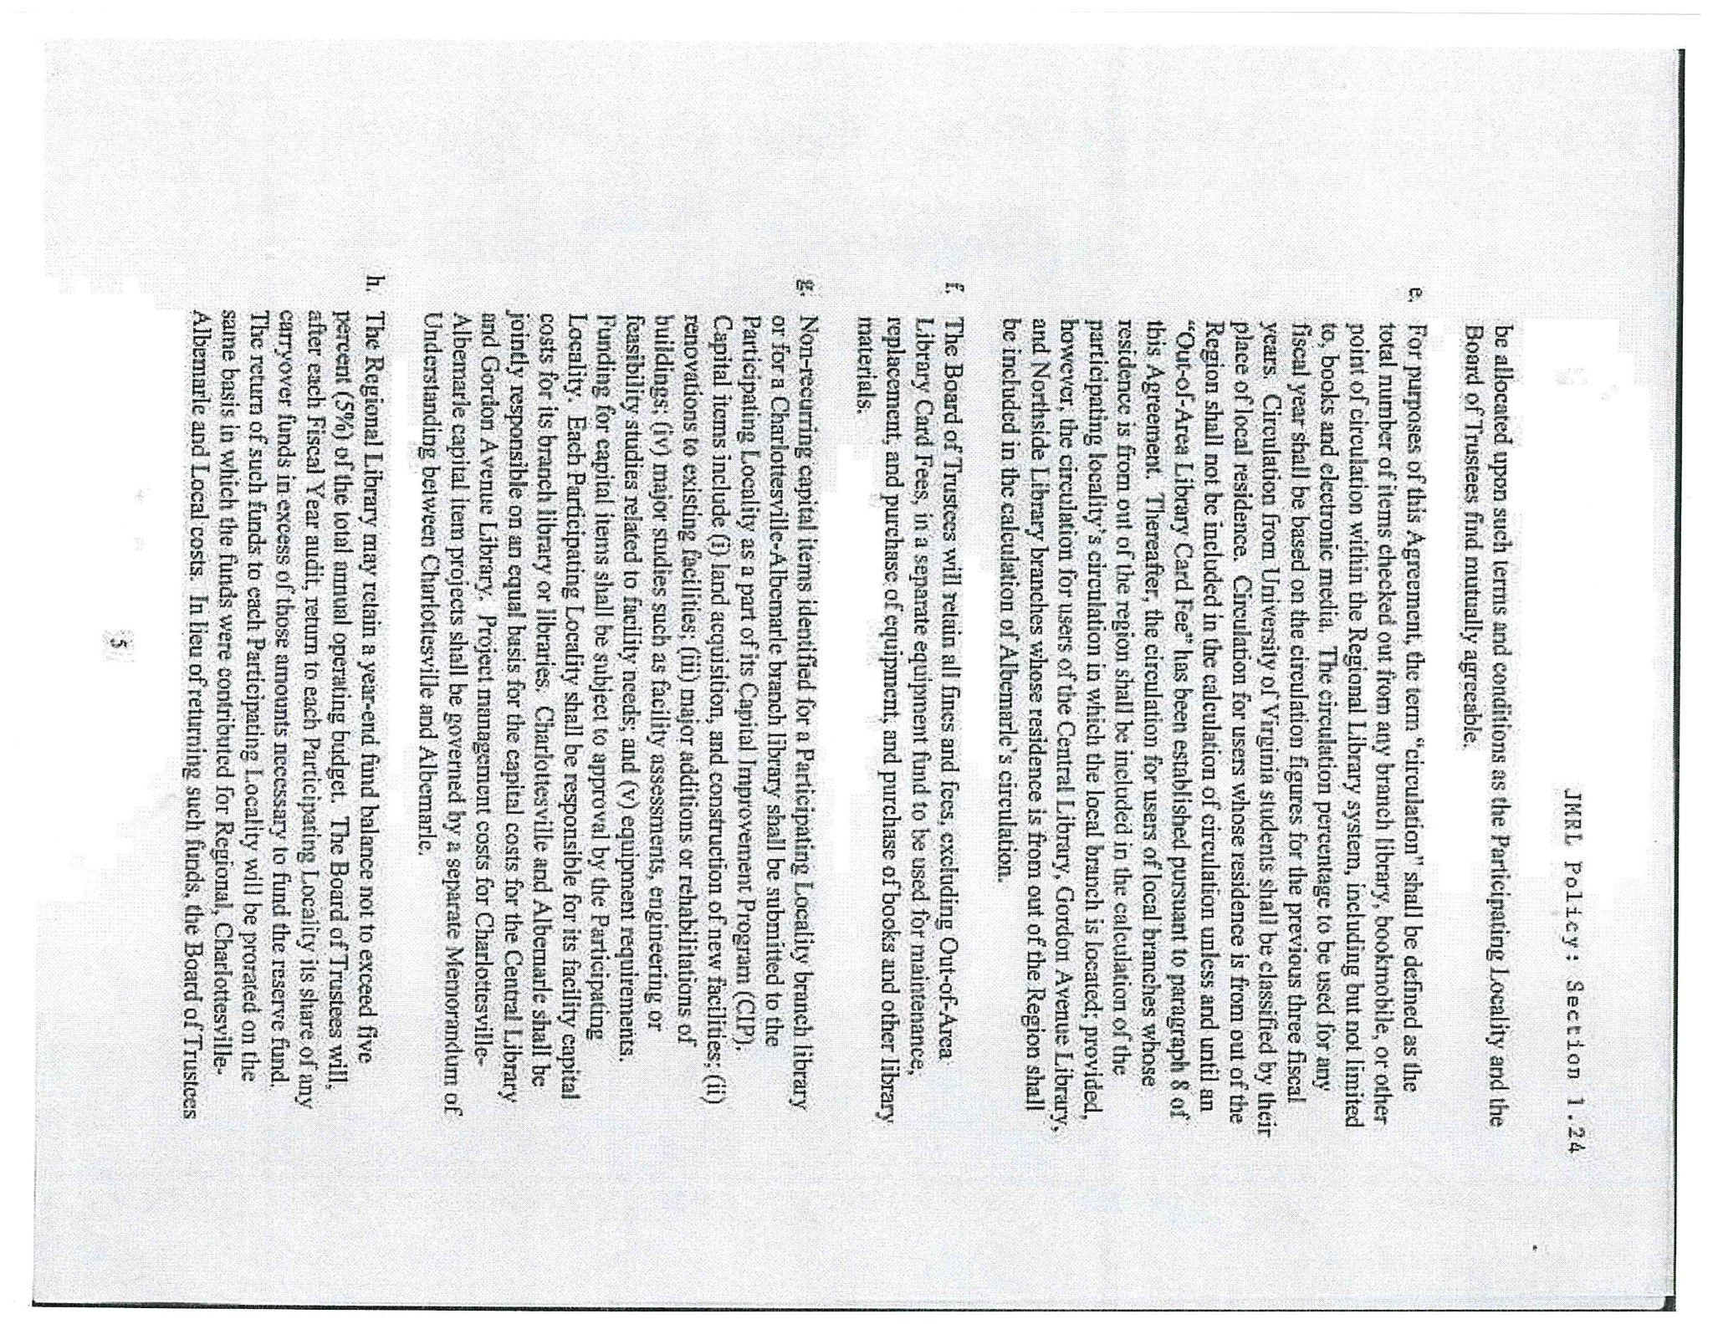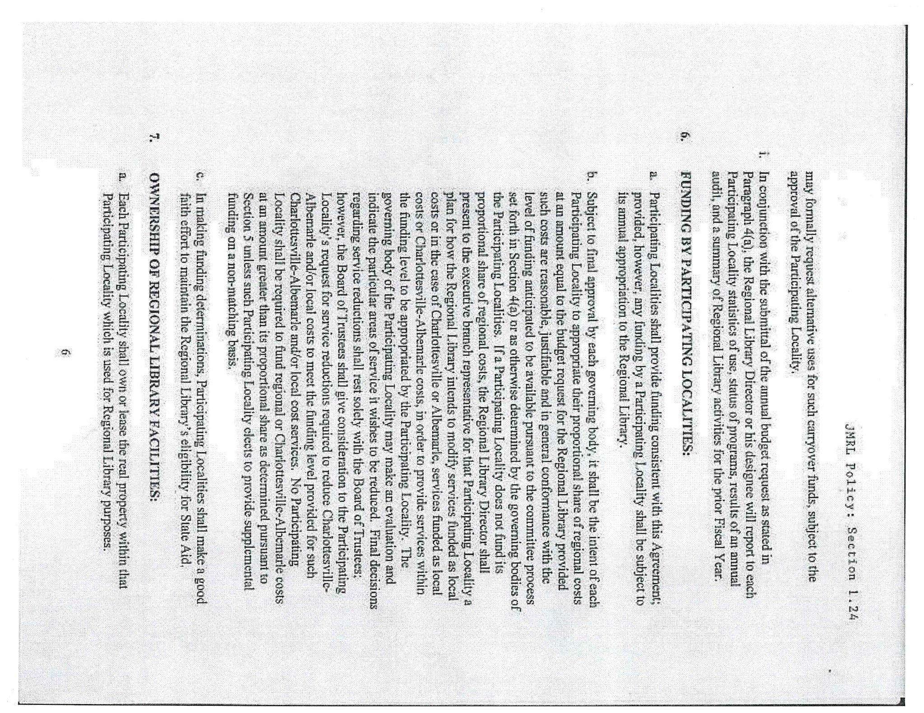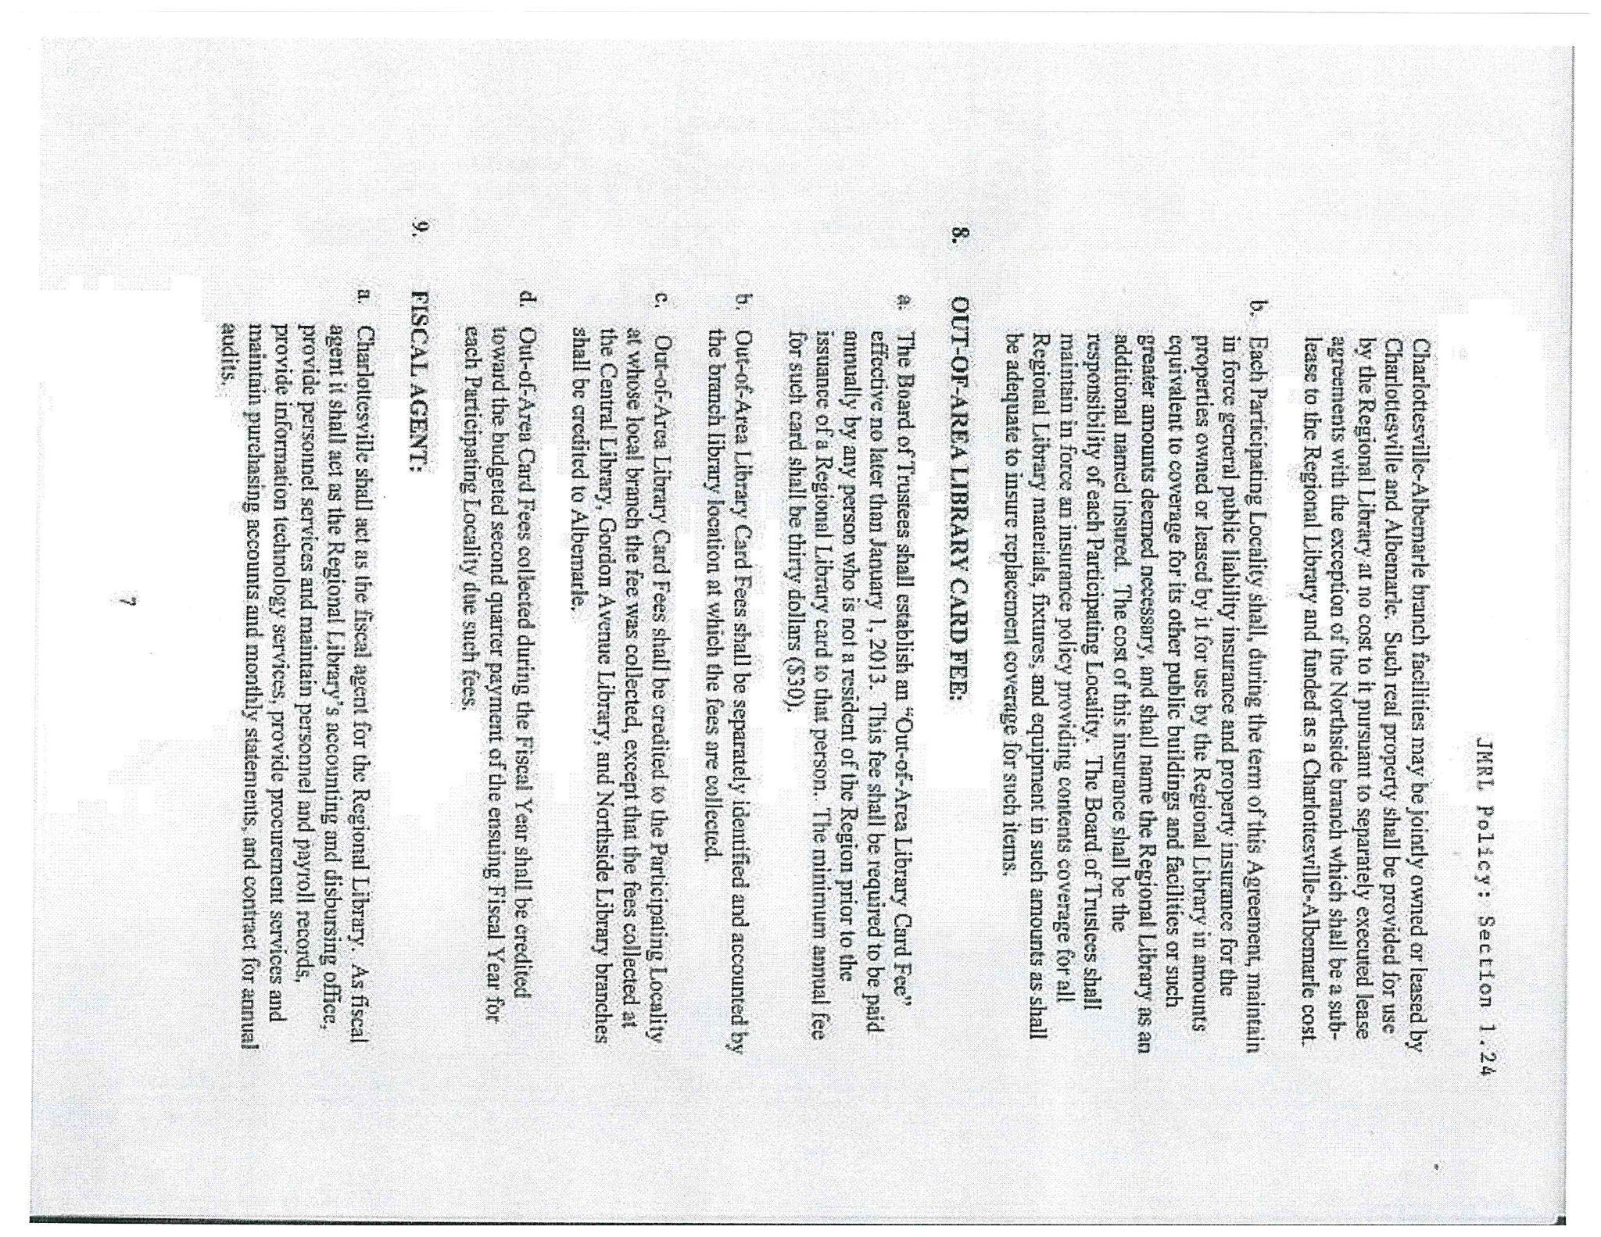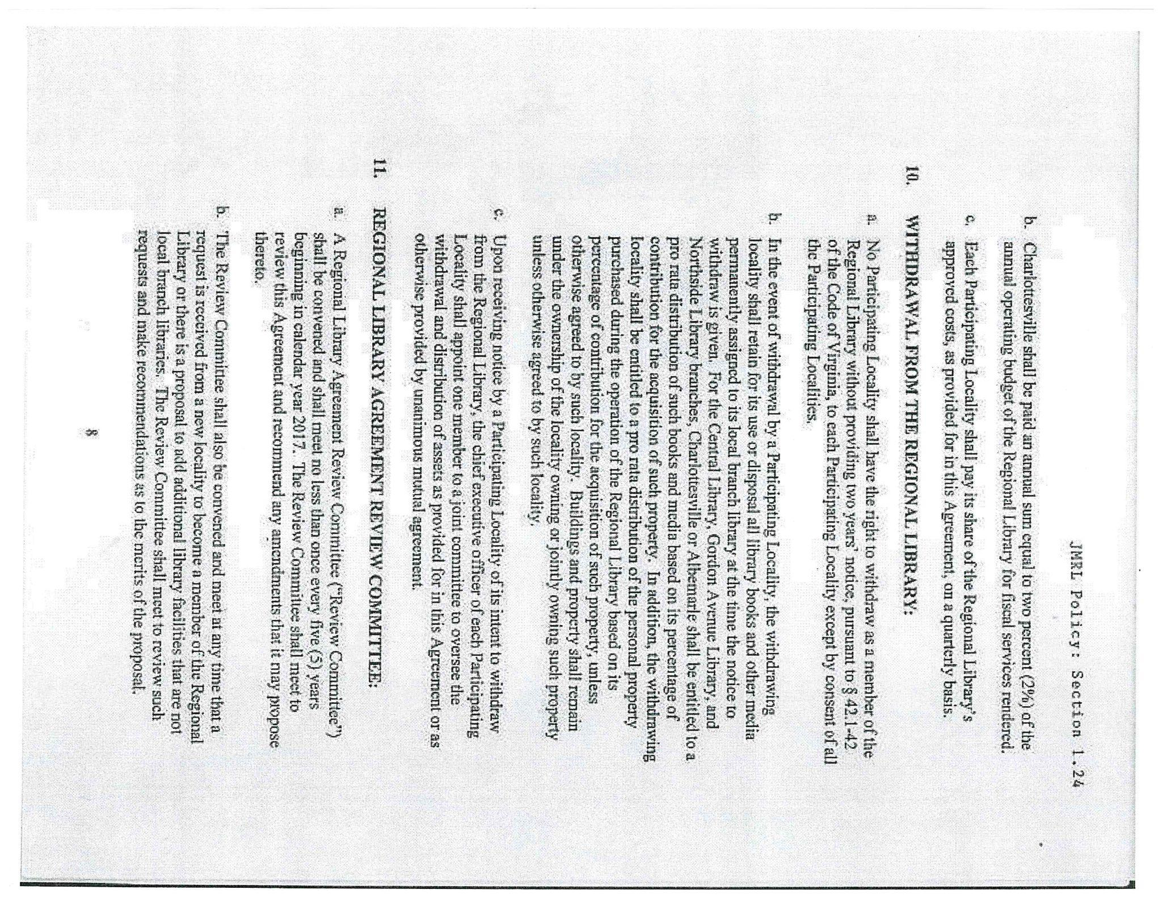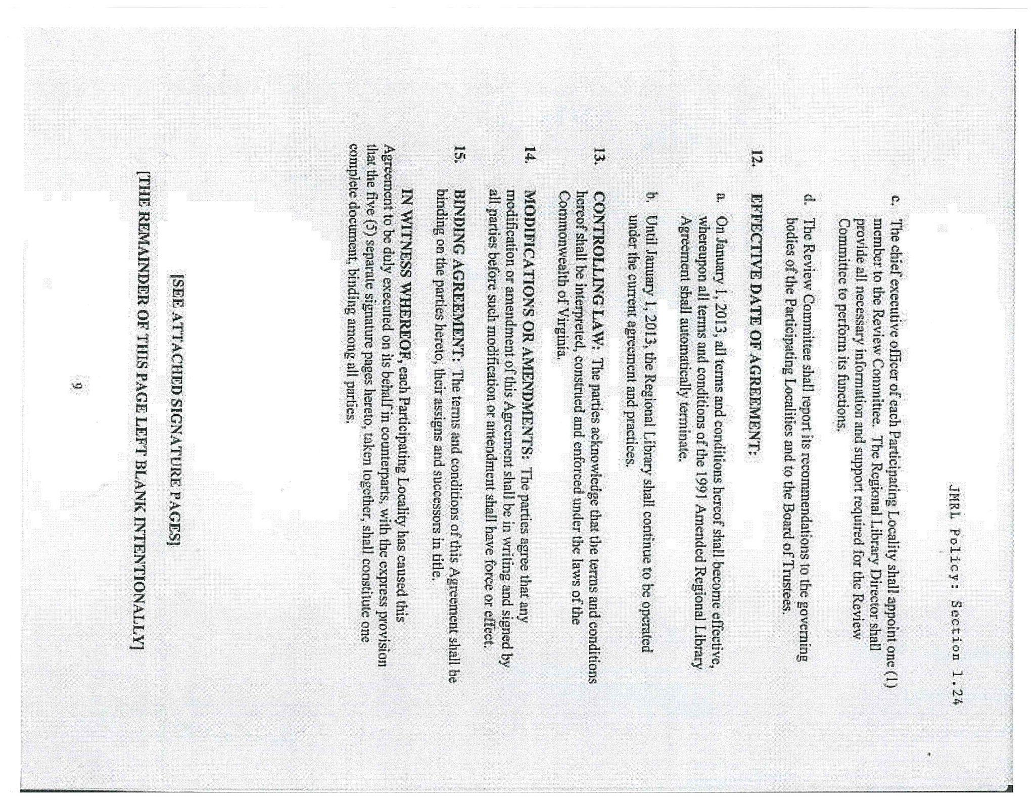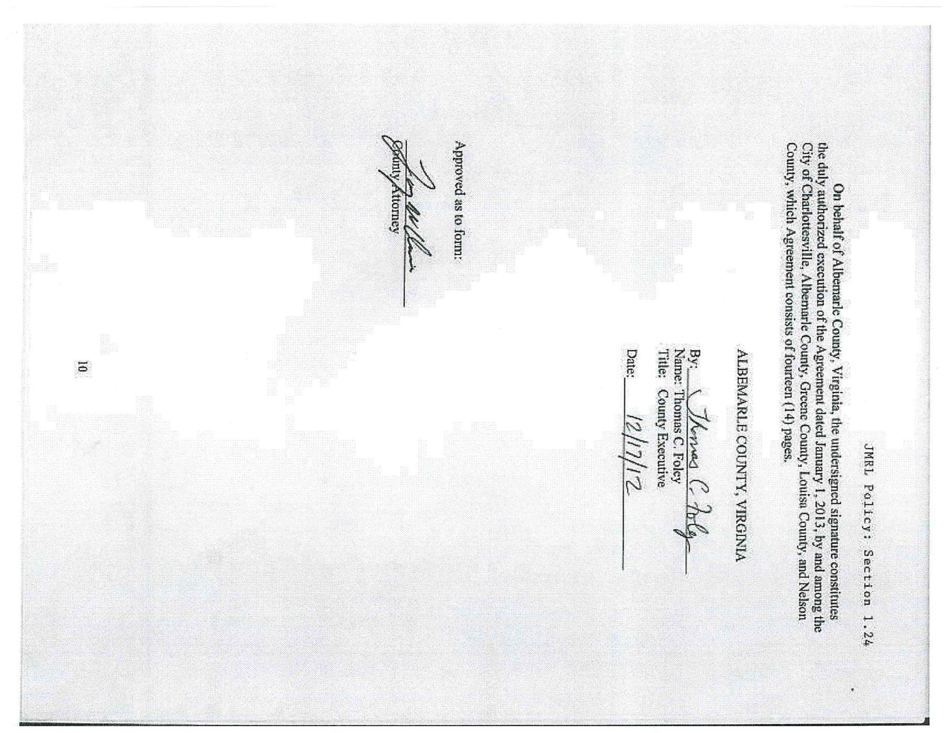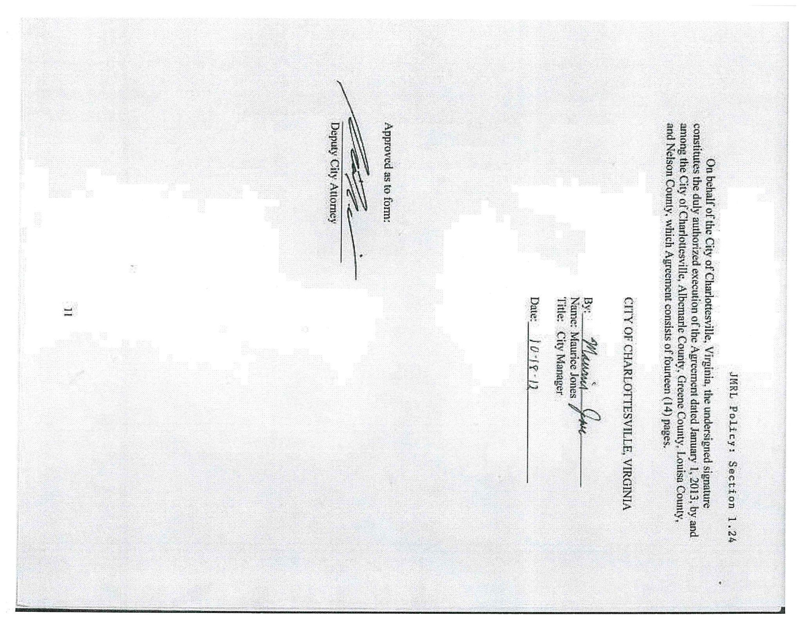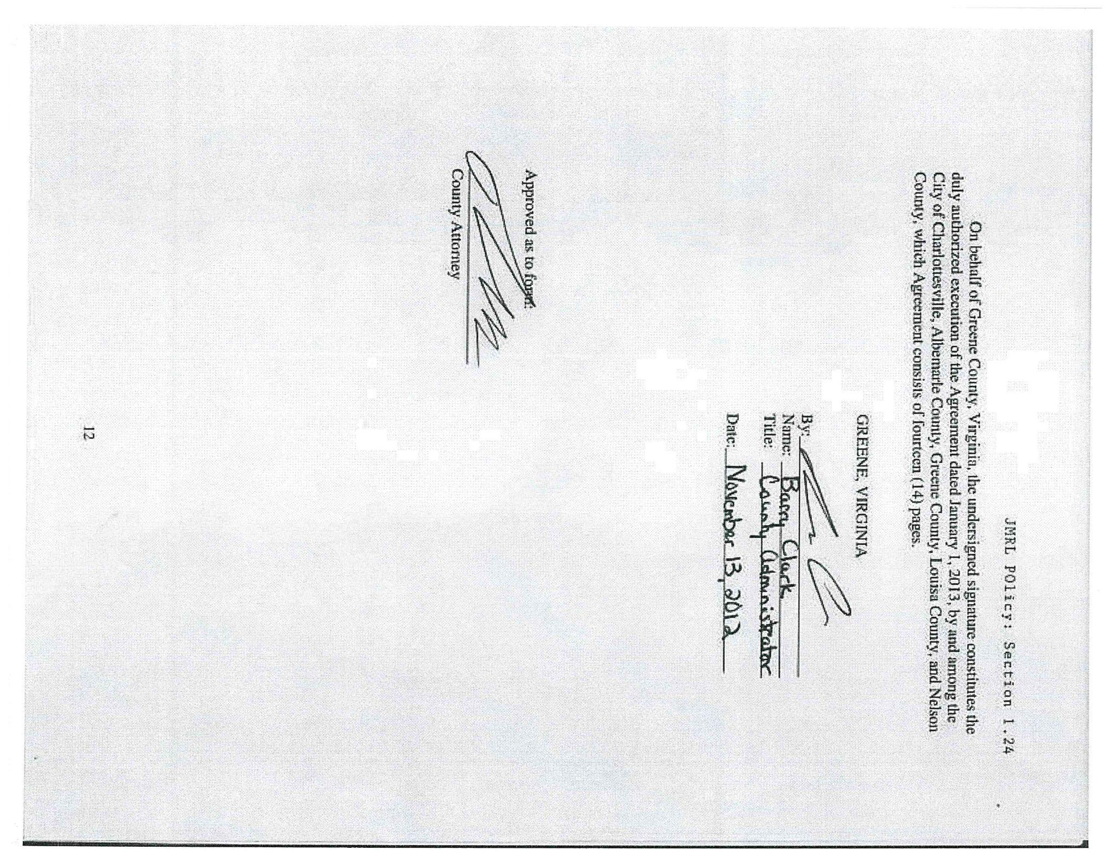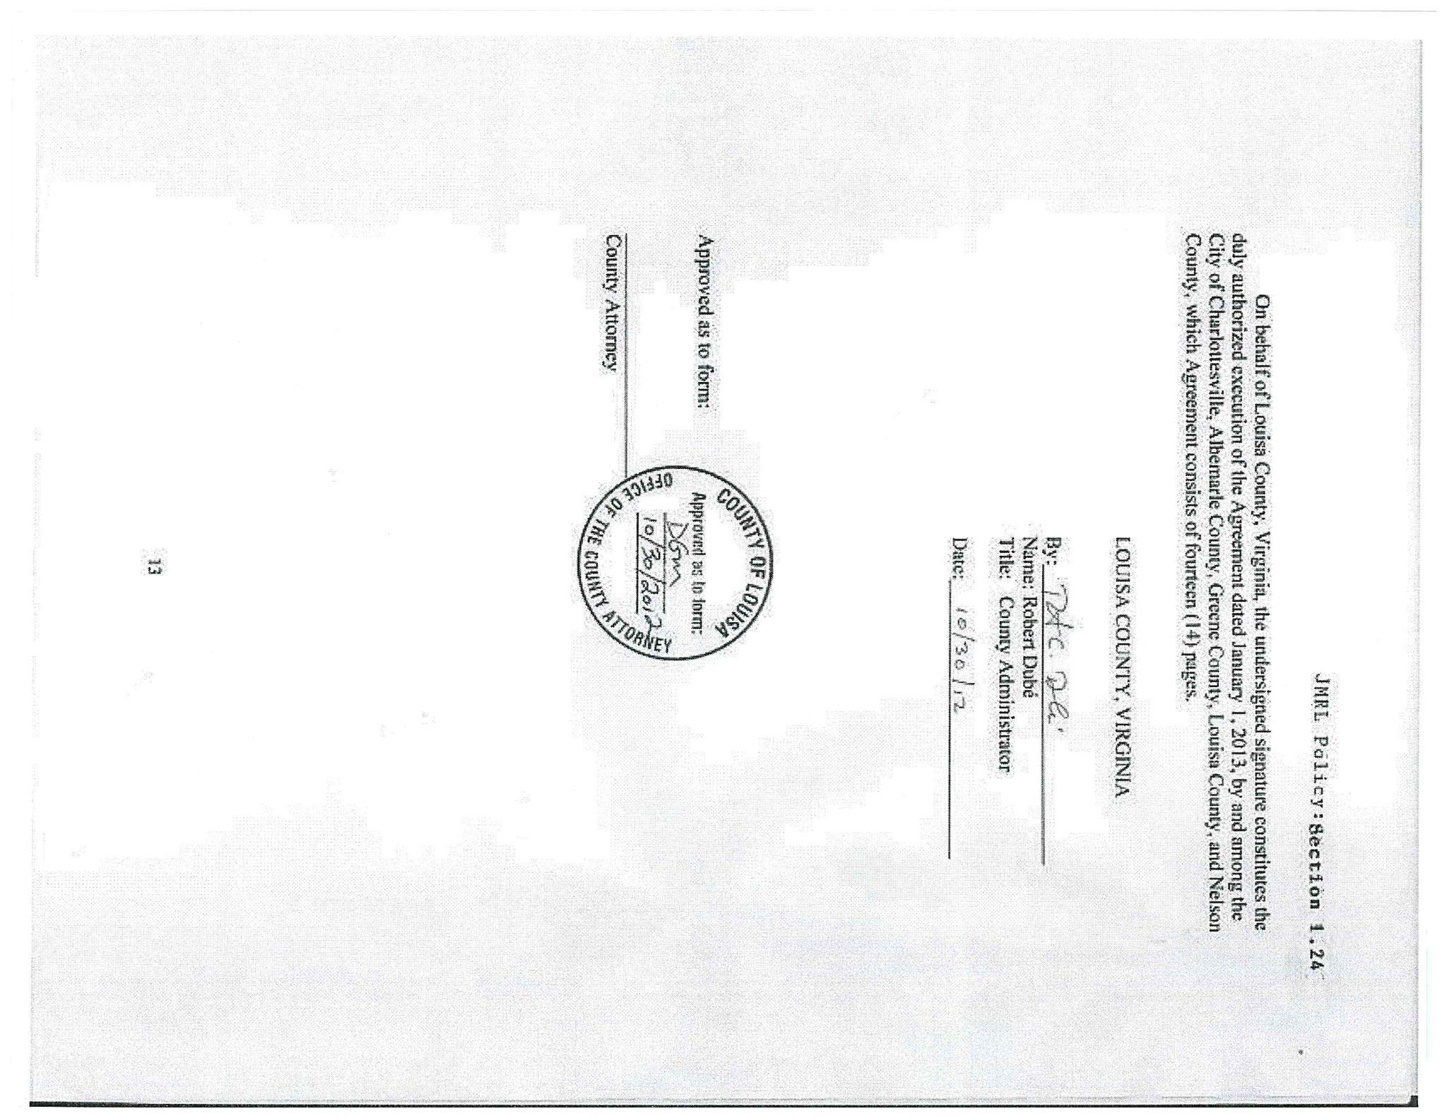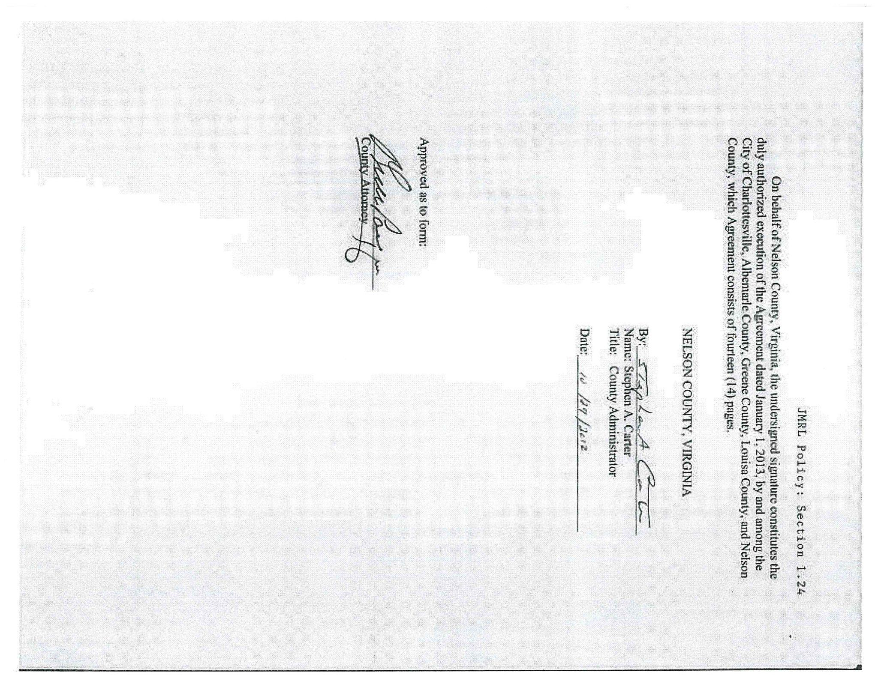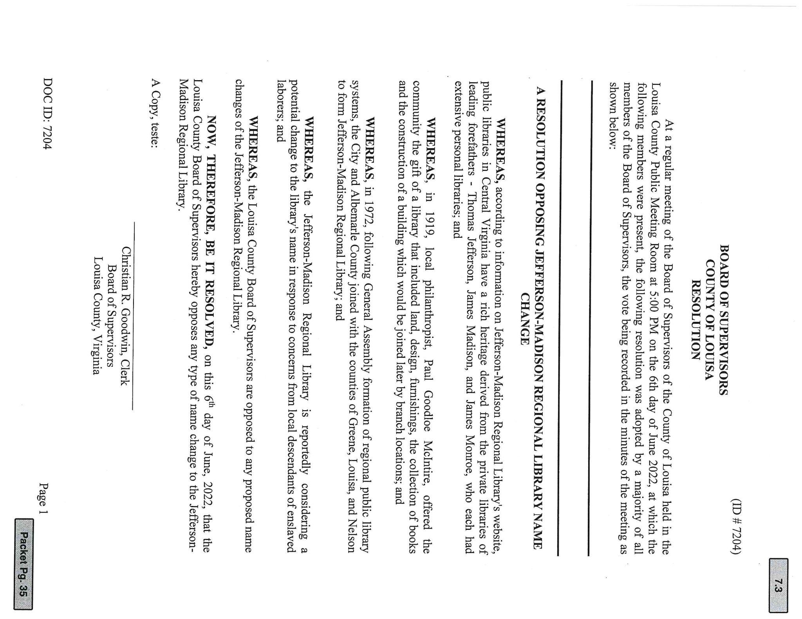

VIA EMAIL

--

- 6/8/22

Dear Mr. Plunkett,

Please see attached a letter on behalf of the Louisa County Board of Supervisors.
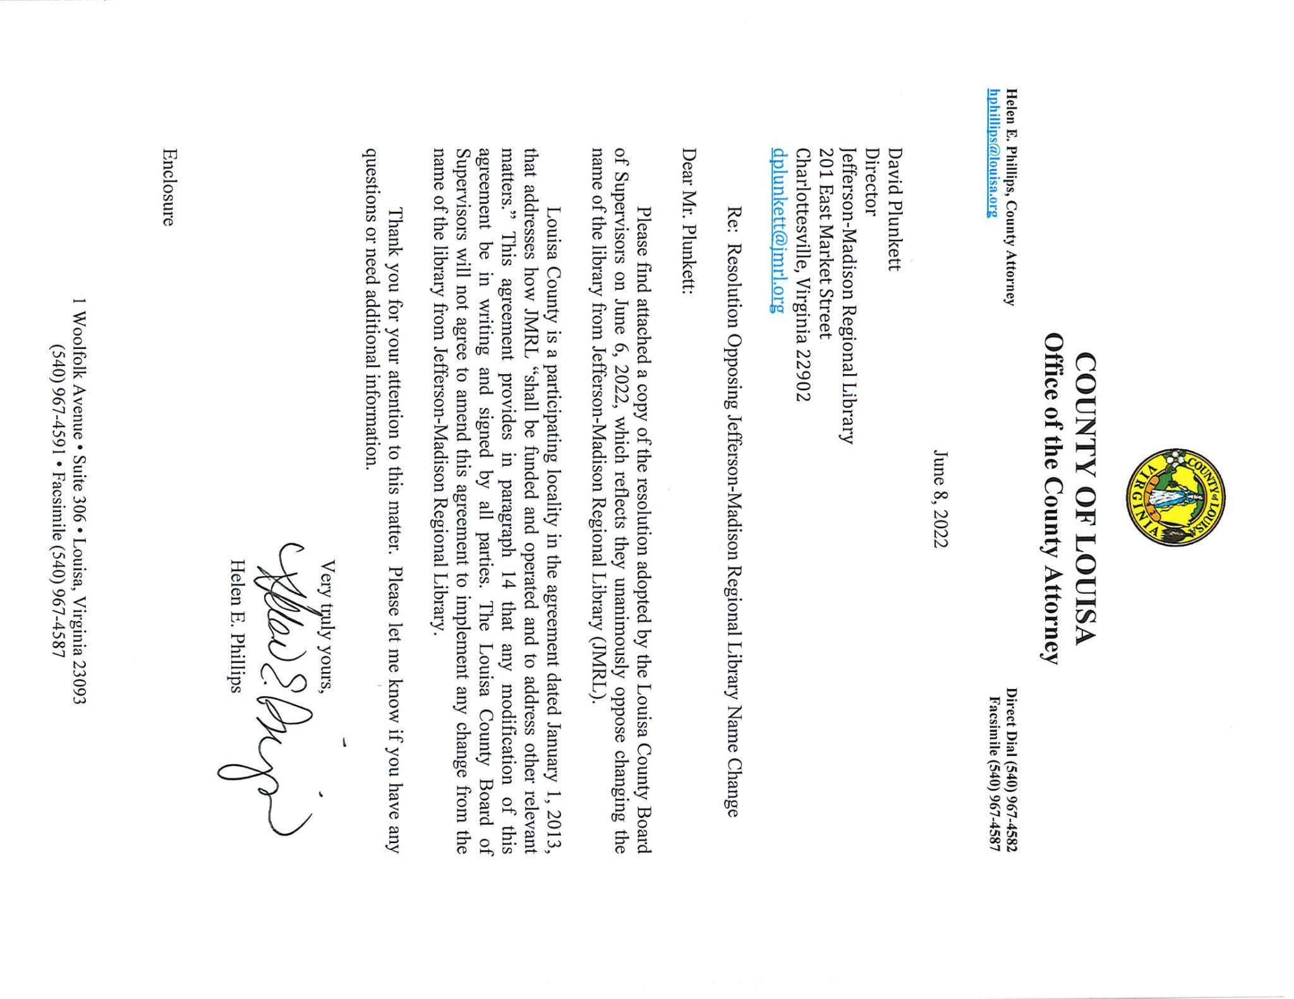
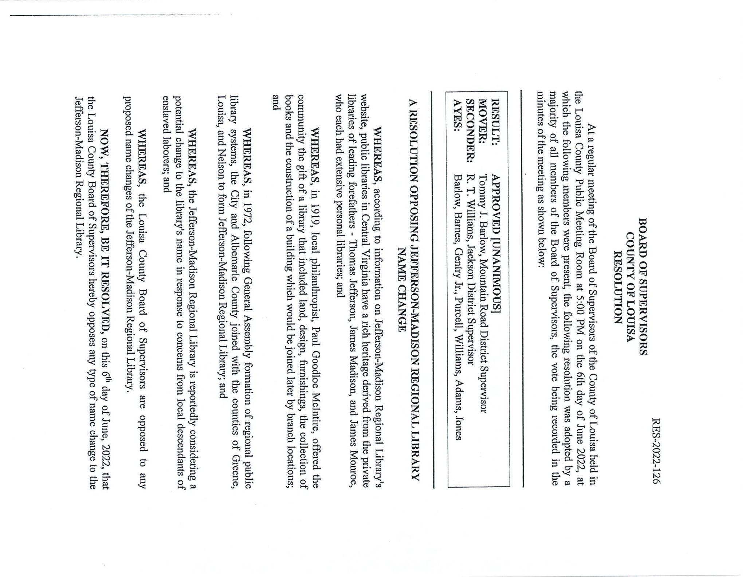
LOUISA VIA EMAIL

--

- 6/8/22

DONT CHANGE THE NAME. IF YOU DO ILL REFUSE TO WORK AT THE ANNUAL. BOOK SALE AND REFUSE TO BUY ANY ALSO

VIA EMAIL

--
- 6/8/22

Please Don't Erase Our History BY Changing Name of Library System

Enough is enough!

VIA EMAIL

--

- 6/8/22

Please, leave the names of these outstanding men on the name of the library.
This does not deny anyone library privileges.
What good have removing statues done?
We are spending millions of dollars that are needed for housing, food and education.
Too much money spent for political people wanting publicity.
Thank you.

VIA EMAIL

--

- 6/8/22

Dear Mr. Plunkett,

I write as a resident of Charlottesville since starting law school at U VA since 1977 regarding the proposed name change of the Library. I urge the Library to keep the name. Jefferson was the 3rd president of the USA, the drafter of the Declaration of Independence and founder of U VA. Madison was a key draftsman of the Constitution, and the 4th president of the USA.

We should continue to feel honored to have such esteemed men living in our area.

Regarding their being slave holders, which I understand is the principal objection to keeping the name, we shouldn’t overlook these accomplishments solely on the basis of judging them by contemporary standards. Abraham was a slave owner, and is still recognized as the founding father of 3 chief religious faiths. Jesus never spoke against slavery.

Thank you for considering these views.

Very truly yours

CHARLOTTESVILLE VIA EMAIL

--

- 6/8/22

Really, this is a step too far. We can't erase history by taking people's names off of things. And these two men should be honored for the numerous contributions they made to our society, culture and community. I'd like to put any one of the folks demanding this name change--or any of you or any of us, for that matter-- to put their own lives under a microscope and come up sinless. Only one man has ever lived up to that challenge and I don't think He would condemn either Jefferson or Madison, but would forgive them their faults and celebrate what they accomplished, despite having feet of clay. How long are we going to put up with this cultural upheaval that's mainly designed to make a few people feel more important politically? Will you bend to the current wave or stand for what's reasonable and right?

I, for one, will destroy my library card and let the agitators have the library; let's see how many visitors/users you have if the rest of us, who aren't offended, stop coming. The cost of renaming things is astounding, and I am appalled that ANY of my tax money might be used for such a worthless exercise in nothing more than political correctness.

I URGE you to please vote NO to changing the name of the library.

CHARLOTTESVILLE VIA EMAIL

--

- 6/8/22

Mr. Plunkett,
I read the article in the Daily Progress about the group that is pressuring the Library Board of Trustees to change the name of our Jefferson-Madison Regional Library.
While I understand their desire to divest of any historical references to the evil that was slavery, I disagree that a public library is simply supposed to be a safe space. A library is full of books that tell the stories of good and evil, of fantasy, fiction, and facts. That fact is Jefferson and Madison were founders of this country and wrote this constitution that gives all of us equal rights and opportunities. Jefferson and Madison were both lovers of books and histories and had fantastic libraries.
I don’t know the history of the regional libraries. I don’t know why or when the libraries were renamed to the Jefferson/Madison Regional Library, but it would be a shame to once again simply revise history and pretend that Jefferson and Madison don’t matter, all because of pressure from the current social justice movement. Please take this into consideration as you meet with the board in the coming weeks.

A lifelong lover of books and libraries,

ALBEMARLE VIA EMAIL

--

- 6/9/22

This attack on two of our Founding Fathers is ridiculous. They were flawed men. We all know that. But their brilliance in building our country is unparalleled in the history of the world.
If not for Jefferson, we would not have a Library of Congress. If not for Madison, we would not have the US Constitution, mostly written in Orange County Virginia.
Stop the madness. Leave the name of the library alone.

CHARLOTTESVILLE VIA EMAIL

--

- 6/9/22

Please reject any effort to change the library name. Jefferson and Madison were reat Americans. Tell the slave descendants group to get a life. Live for the future, not the past.

VIA EMAIL

--

- 6/10/22

Dear Director Plunkett,
I'm writing as a concerned Albemarle County citizen to protest the proposed name change of our beloved local library. While our founding fathers didn't uphold our current values, things have truly changed in our Commonwealth and we should be looking forward and working on real solutions to our many current problems rather than focusing time, efforts and financial resources on such ultimately meaningless gestures.
We can't - or shouldn't - try to erase history. We should remember and thus learn from it and our past mistakes. We should seek to unite going forward in tangible measurable ways and means rather than be divided over the dustbin of history.
Thank you for considering my comments and I pray that we leave our posterity intact and strive to brighten our shared future.

ALBEMARLE VIA EMAIL

--

- 6/10/22

Dear Sir:
I am a resident of Keswick and graduate of the University. My wife is a retired librarian who was Director of a Carnegie Library in Clarksdale, Mississippi and Memphis, Tennessee. She experienced both libraries decline due to policy decisions by both cities. I would like to challenge you to think before you act; the removal of Jefferson and Madison as the name of this library is total insanity.

The attempt to erase history is right out of the book, that of Cloward -Piven and Saul Alinsky's "Rules for Radicals". Do not fall for this and leave well enough alone. My wife who has a Masters in Library Science and served as head of two and worked in three from Jackson, Mississippi, Clarksdale Mississippi and Memphis, Tennessee, would be glad to offer her advice on this or any other issue concerning good governance.

We applaud the unaminous vote of the Board of Supervisors from Louisa County.

ALBEMARLE VIA EMAIL

--

- 6/10/22

Dear Mr. Plunkett,

Here you are. Our library director. Presumably, at one time, a
librarian. A lover of books, maybe? Perhaps, with a tad of history under
his belt? Perhaps with a respect for culture, for the roots of a community?

Nah..... Sadly you are instead a creature of politics. You are a
creature climbing up the dirty rungs of ambition to further your own
itsy-bitsy career. You are a symptom of what is killing our culture.
You are just ONE person, and yet you will personally cancel the men and
women who became this nation's models for humanity. You will commit this
atrocity just to be popular with the people who scream the loudest.

Mr. Librarian, presumably "book lover", I strongly suggest that you
read biographies of Thomas Jefferson and James Madison. I suggest you
learn about their extraordinary accomplishments, their erudition, their
large spirits, interesting lives, and ultimately, their goodness. It is
their accomplishments that put this country on the road to freedom and
stability. They made your itsy-bitsy life possible. You should feel
grateful to these intellectual giants.

But... ah, I doubt it. Knowledge is not your forte (pronounced:
for TAY.) That means strength.

You are an intellectual midget, and an emotional weakling. Do what
you will do.

VIA EMAIL

--

- 6/10/22

Please note that I am opposed to the name change.
Presidents Jefferson and Madison were two of the
founders of this country and helped create the
greatest country on earth.

VIA EMAIL

--

- 6/11/22

I find it appalling and disgusting that changing the library name is even being considered. I’m tired of a FEW people trying to wipe out historical figure names who gave so much to this country. History tells us we have made mistakes in the past…..you learn from it & do better but you don’t try to ignore what happened. Stand up to this issue.

VIA EMAIL
--

- 6/11/22

Dear Mr. Plunkett,

I am writing to OBJECT to the proposed name change for the
Jefferson-Madison Regional Library.

This is yet another attempt to erase and re-write history. This is what
the communists did in the Soviet Union and China. They eliminated
history as well as people. They started by destroying monuments and
changing building names. It's a creeping demolition of a society to
generic everything.

People who don't know their history, good and bad, tend to repeat the
bad. Not one of us is without flaw and our founding fathers were no
different. But look what they created!

Without Jefferson and Madison, we wouldn't have a Declaration of
Independence, a Constitution OR a USA. This country is a CONSTITUTIONAL
REPUBLIC, not a democracy.

DO NOT CHANGE the name.

CHARLOTTESVILLE VIA EMAIL

--

- 6/11/22

I absolutely OPPOSE changing the name of the Jefferson-Madison Regional Library.

It’s about time people stand up for what is right and not be intimidated by this small woke group of “laborers”. If they don’t like it, they can move!

You can’t change history!!

I oppose

VIA EMAIL

--

- 6/13/22

Dear regional library leadership,

I encourage you to change the name of our regional library.
Our church, the Unitarian Universalist Congregation of Charlottesville, changed our name because:
-the old name didn't welcome diversity
-the old name celebrated a man who enslaved people although he spouted words of equality
with the racial disparities in educational achievement in our community the public spaces with books for children should be welcoming to all
-having the names of people who didn't approve of educating even to be able to read an enslaved population that was at least the same size as the white population
-a name on a building means the organization inside that building holds those people in high esteem and values the actions of those people
Actions speak louder than words.
These same reasons apply to the name of the regional library. Your actions matter.

VIA EMAIL

--

- 6/14/22

I love the Jefferson-Madison Regional Library and go every week to the Central branch; this is my happy place to find new authors to read or to be reacquainted with authors when the publish a new book. And I find the library name most fitting and appropriate, not only for our area, but in light of the contributions to knowledge and life these individuals had on our country. The fact Thomas Jefferson provided a source of books from his personal library to rebuild the Library of Congress speaks to the importance of books in everyone’s life. Please do not change the library name because of a few people who want to show their “wokeness” by playing the race card. You cannot judge people from the past using the standards of today, that is not appropriate and diminishes the contributions they have made. I add my voice and support to all the friends of the Jefferson-Madison Regional Library and the community at large who benefit from the example of past leaders who showed us how important reading and knowledge is to a great society.

CHARLOTTESVILLE VIA EMAIL

--

- 6/15/22

Thank you for your reply, Mr. Plunkett. I express an opinion that is widely shared, I assure you. Too many people are intimidated by leftist mobs and afraid to speak out.
Along with others, I am tired of being stripped of our intellectual heritage, and tired of our history being gutted to pacify uneducated twitter mobs.
Our Declaration of Independence and our Constitution were written by geniuses, worldly, wise and educated individuals. Our Constitution is about one thing, and one thing only -- limiting power -- and those who wrote it saved us from a tyranny that would certainly have sanctioned and embraced slavery throughout our land. We are the only nation on earth that fought a devastating war against itself to end this morally corrupting and socially devastating institution -- 500,000 died so that we could all enjoy the same freedoms. Those who are protesting Thomas Jefferson and James Madison should be taught something about the origins and history of this nation.
There is no perfect human being, no perfect society, no perfect government. But ours comes closest to any. And I say this not from an inflated sense of patriotism but from an acquaintance with history -- my educational specialty and lifelong passion.
Please feel free to pass this letter along to the Library Board as well, for this is the core of my protest.
And I do hope that you all can see your way through, with courage and foresight, to stand firm in support of our cultural and intellectual heritage, and to not give in to those who would obliterate the names of Thomas Jefferson and James Madison from our Regional Library system.

VIA EMAIL

--

- 6/16/22 (two identical letters from same household)

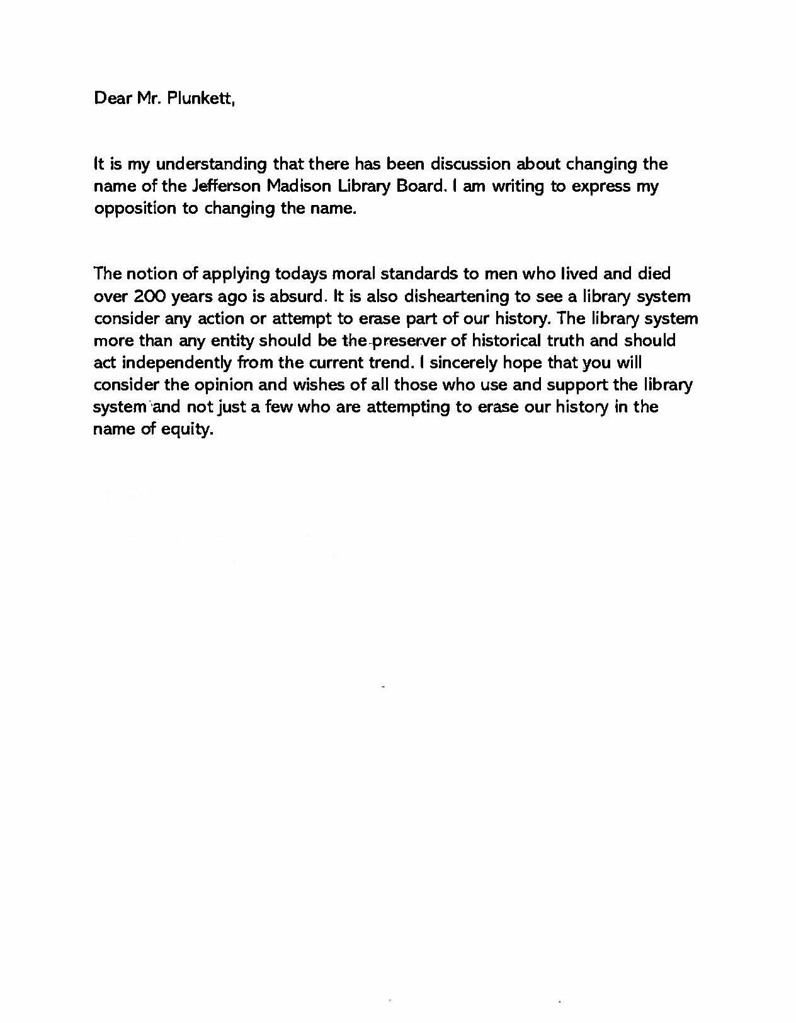
LOUISA VIA USPS

--

- 6/17/22

Hello! On Tuesday, June 14, 2022, the Board of Supervisors of Greene County voted unanimously to pass a Resolution Opposing a Name Change of the Jefferson-Madison Regional Library. I have attached a copy of the Resolution for your consideration.

Thank you!
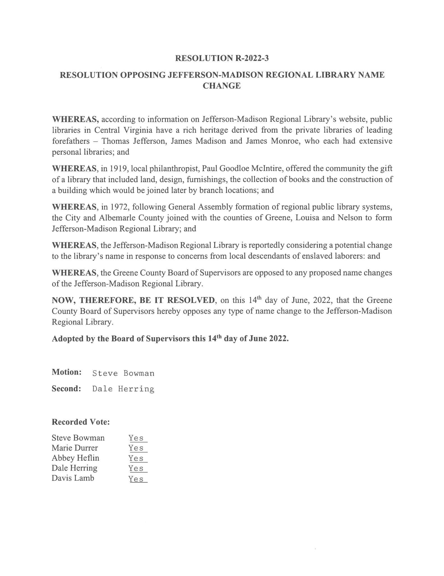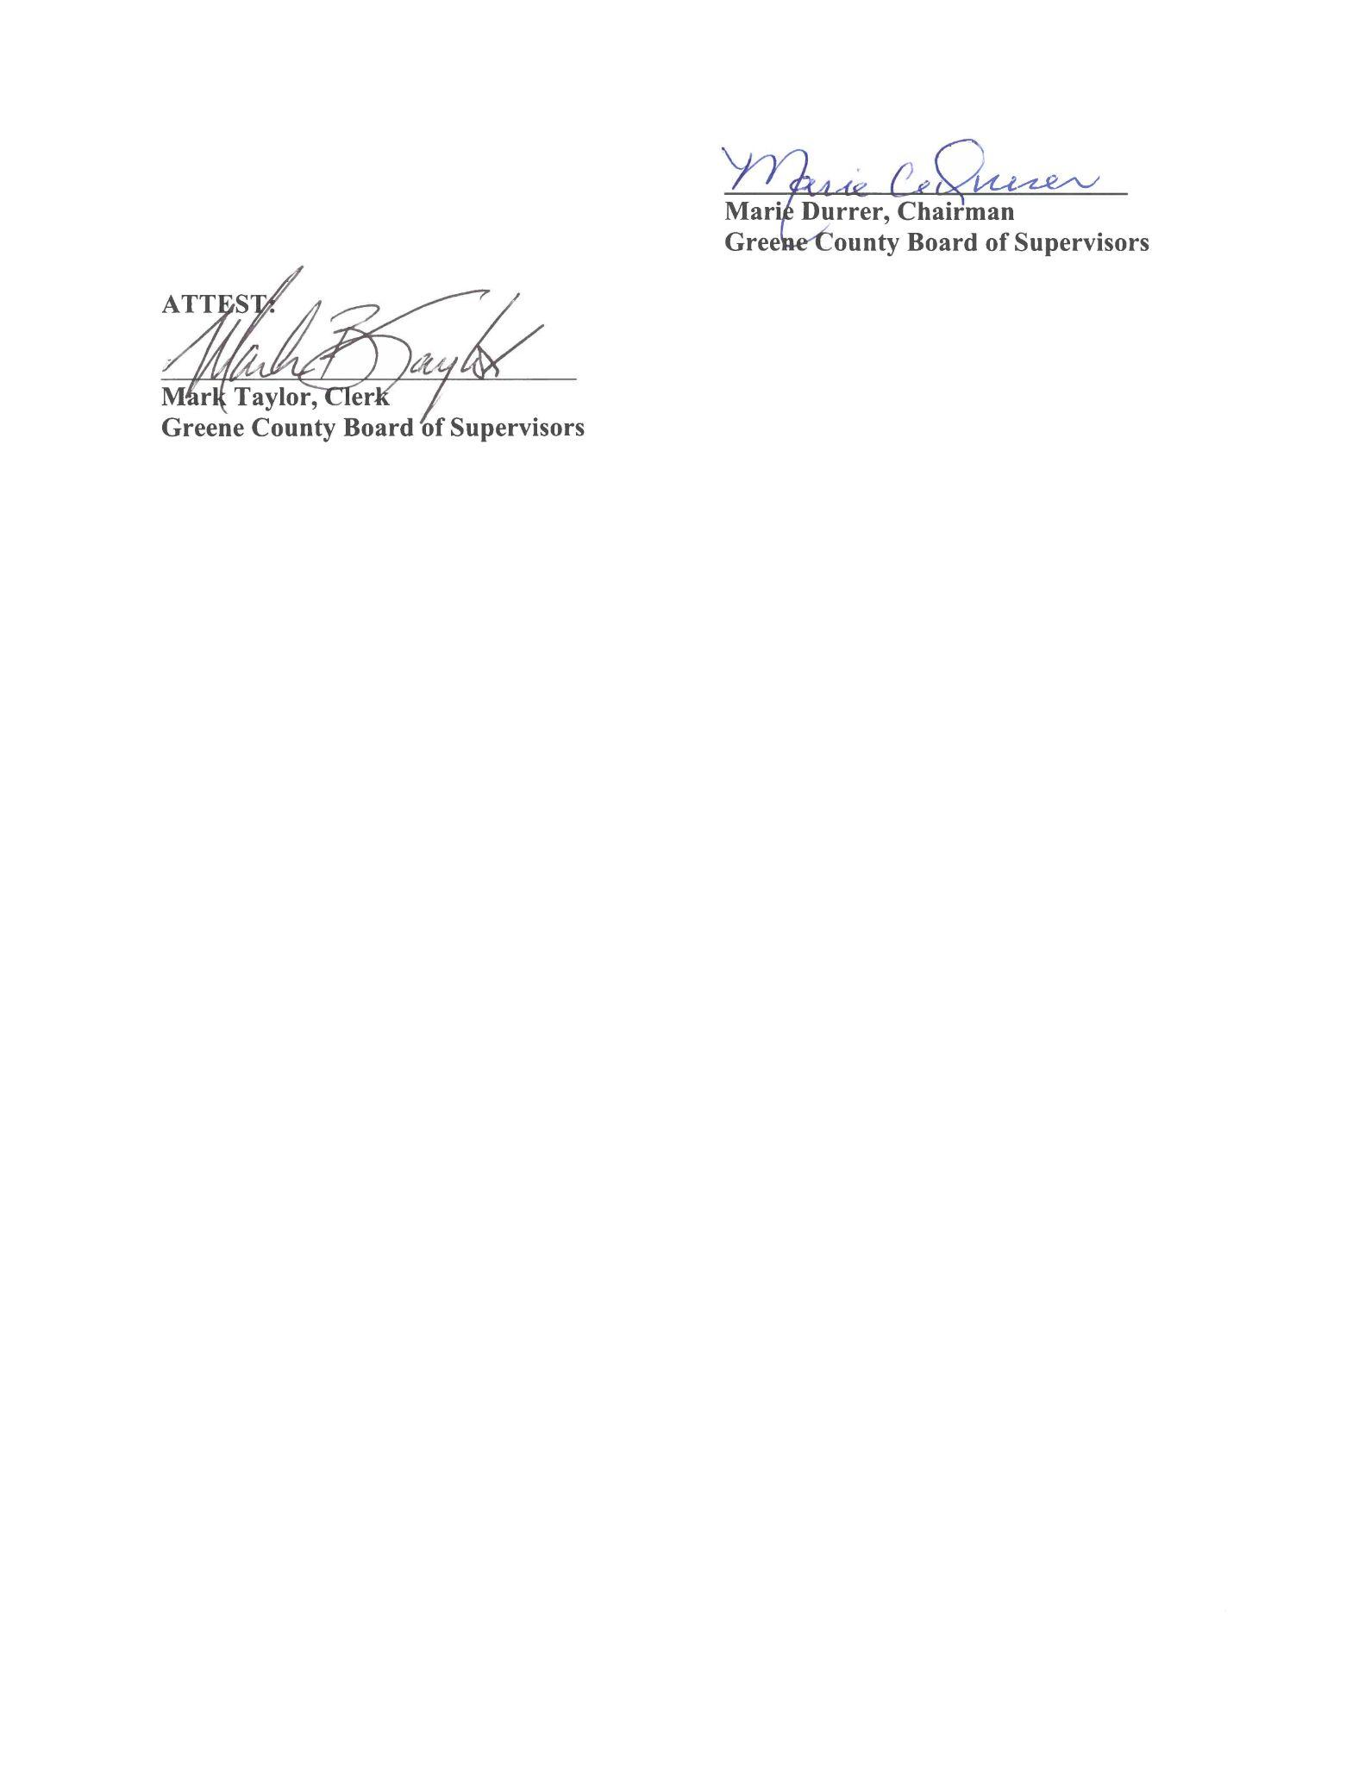
GREENE VIA EMAIL

--
- 6/17/22

Mr. Thomas Unsworth President Board of Trustees Jefferson-Madison Regional Library 201 East Market Street Charlottesville, VA 22902 Dear Mr. Unsworth: I am writing to express my outrage at your proposal to eradicate Thomas Jefferson and James Madison’s names from the Charlottesville Regional Library. You have heard from the “Reclaimed Roots Descendants Alliance.” It is time you also heard from University of Virginia alumni and true students of history who view our nation’s leaders in the context of their times, not through the prism of historical revisionists. Our Founding Fathers must be judged in comparison to their American and global peers, not by the uninformed criteria imposed by radical leftists who analyze all by their narrow minded perspectives of virtuous behavior. In the fall of 1969, I was considering attending one of my top two college choices: Georgetown or Virginia. My father, sister, and many relatives went to Georgetown. I was attending Canisius High, a Buffalo Jesuit high school, and my Jesuit priest college counselor made it clear that attending the premier Roman Catholic university was pretty much a no brainer. However, my oldest brother was a career Army officer, attending UVA for a Masters in International Relations at the Woodrow Wilson School after an earlier tour in Vietnam. He implored me to visit UVA and strongly consider attending Virginia over Georgetown. After a tour of the Lawn, viewing the Rotunda and hearing the history of the University, I was sold. When I was accepted, I chose UVA immediately. Anticipating your perception of me, I was not a child of “white supremacist privilege.” I attended UVA on an Army ROTC scholarship. My father was retired, and I could not have afforded the UVA out-of-state tuition without the scholarship. I chose UVA because of Thomas Jefferson. We are the only university in America founded by a Founding Father. I majored in History and loved every minute of my four years’ attendance. If you remove Jefferson and Madison’s name from your library, you are spitting in the face of every American patriot and leader who resided in Maryland, Virginia, and other southern states. By today’s moral criteria, support of slavery seems morally indefensible. However, you have to consider that literally every Western country condoned slavery two centuries ago. In case you are unaware of this fact, African slaves were sold by warring tribes to English slave traders. Moral complicity runs far and deep. Eradicate Jefferson and you need to also eradicate all the African tribal leaders and English ship barons who transported the slaves to America. Where does your ethical indignation and hubris end? Jefferson clearly had moral qualms about slavery, and even proposed bills to eliminate the importation of slaves. I’m pretty sure that you didn’t know that or if you did, ignored this historical truism. I believe in facts, not woke revisionism. Read this article: https://www.tjheritage.org/jefferson-and-slavery. By the standards of his times, Jefferson was a liberal radical. Because you and the “Reclaimed Roots Descendants Alliance” apparently didn’t do your historical homework, you are unaware of this. Furthermore, the core premise of this group has been refuted by a scholarly study that has now been buried or ignored, the “Scholars Commission” from two decades ago. The articles below bely Thomas Jefferson’s relationship with Sally Hemmings: • https://www.nas.org/blogs/article/jefferson-hemings_revisited • https://www.tjheritage.org/the-scholars-commission If you care about truth and objective historical analysis, read these articles. Your proposal to remove Thomas Jefferson and James Madison from the Charlottesville Regional Library is beyond unconscionable. If you truly believe you cannot tolerate their names adorning your library, then move to New York, California, Illinois or another locale that agrees with your absurd historical conclusions. You live in Charlottesville, the home of one of our two preeminent Founding Fathers. Deal with it.

OA VIA EMAIL
--

- 6/18/22

message: Dear Lindsay Ideson, please see my letter below: 23233 June 18, 2022 Mr. Thomas Unsworth President, Board of Trustees Jefferson Madison Regional Library 201 E. Market Street Charlottesville, VA 22902 Mr. Unsworth, Without a doubt, the motion to remove the names of Thomas Jefferson and James Madison from the Regional Library stretches credulity. What could you and each member of the Board of Trustees have done -- from the moment you were born -- without the learning and wisdom passed down by these two great Founding Fathers? Would you have had the opportunities that you have enjoyed? Certainly not! Let’s review a bit of what Thomas Jefferson did as a gentleman and a scholar: *at age 9, Jefferson studied Latin and Greek *at age 14, Jefferson studied classical literature and additional languages *at age 16, Jefferson entered the College of William & Mary *at age 19, Jefferson studied law under George Wythe *at age 25, Jefferson was elected to the House of Burgesses *at age 33, Jefferson wrote the Declaration of Independence and revised the legal code of Va *at age 36, Jefferson became the Governor of Virginia succeeding Patrick Henry *at age 41, Jefferson became the minister to France Not to mention, he assumed responsibilities as a husband, father and grandfather, a farmer, a builder and architect, a scientist, and a citizen. Thomas Jefferson served as Secretary of State under George Washington, third President of the U.S., where he doubled the land of the United States through the Louisiana Purchase. He assisted with writing the Monroe Doctrine; dealt with terrorists in the Barbary pirates; founding the University of Virginia and wrote the statute on Religious Freedom. No one has a record of accomplishment like Mr. Jefferson, and you want to REMOVE his name?! What does that say about your judgement as leader of a library? And what about the record of James Madison, you ask? This, the “Father of the Constitution” is surely hated by those who want to eliminate our Constitutional rights. Are you one of those? Let’s look at his record: *1779 elected to the Continental Congress *1787 served at the Constitutional Convention *1789 elected to the US House of Representatives *1801 appointed Secretary of State *1808 elected President of the United States *1812 re-elected President; recommended War with Great Britain **1829 served in the Va. Constitutional Convention The fool-heartiness of removing these two distinguished public servants from this network of libraries, is not lost on many in the Charlottesville Regional Library’s five jurisdictions. We do not want this. As a young girl in Charlottesville, my parents took me to the regional Public Library, one of many children taken to the library, BECAUSE of the names of Jefferson and Madison. Rainy days spent in the library, reading history and learning about many subjects are some of my favorite childhood memories, just up the road from my school, Venable Elementary. This may be the main reason you want their names removed. You bite the hand that fed you. How do you explain this arrogance combined with ignorance? How could Myra Anderson of the religious studies department at The University of Virginia join in such a mis-guided proposal? As President of the Board of Trustees, I call on you to reject this ‘name change’ due to its obvious historical ignorance. Anyone who would entertain this motion must hold abject animus against this great nation. Anyone in a position of caretaker of our shared literary and historical heritage (which should be shared with our citizens) would reject this lunacy. If not -- if you despise liberty so much -- to the degree that your actions suggest-- I recommend that you re-locate to Venezula or Chile, where you will be under the system of Communism which you clearly espouse. There, the names and legacy of Thomas Jefferson and James Madison will not trouble you, except they will be longed-for by those who wish for free-enterprise.

OA VIA EMAIL

--

- 6/21/22
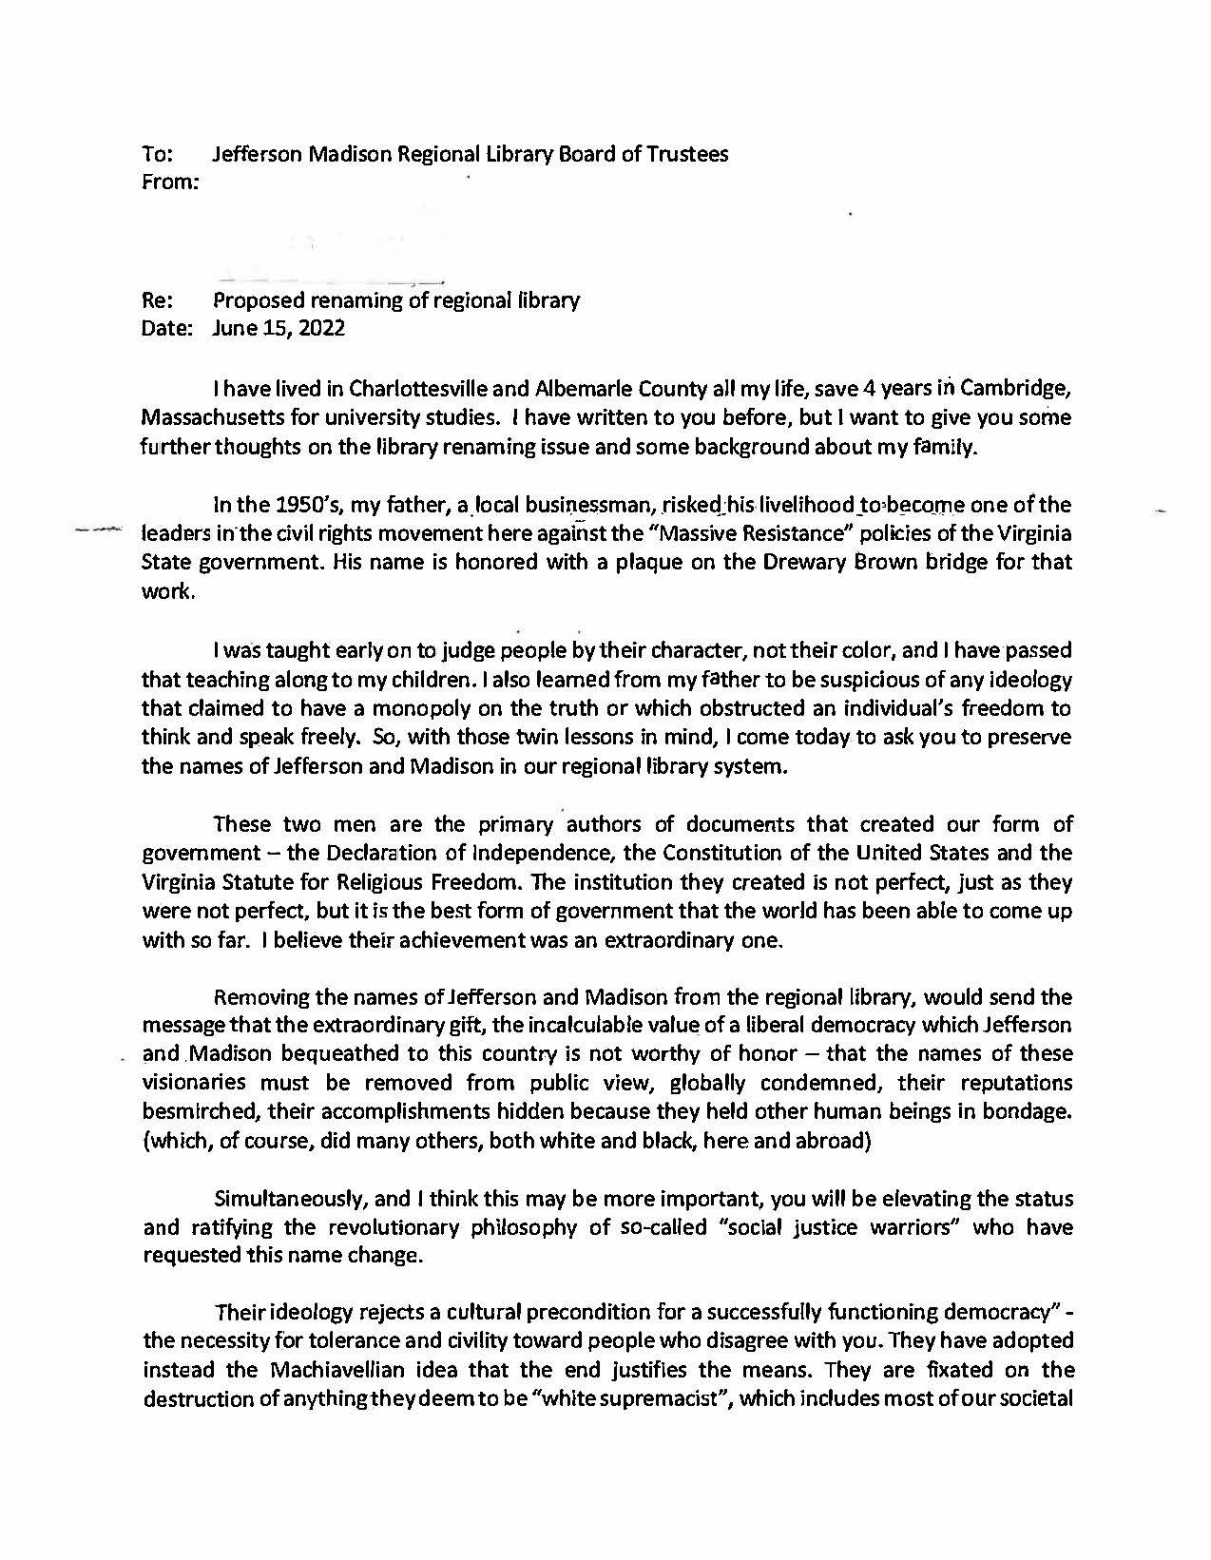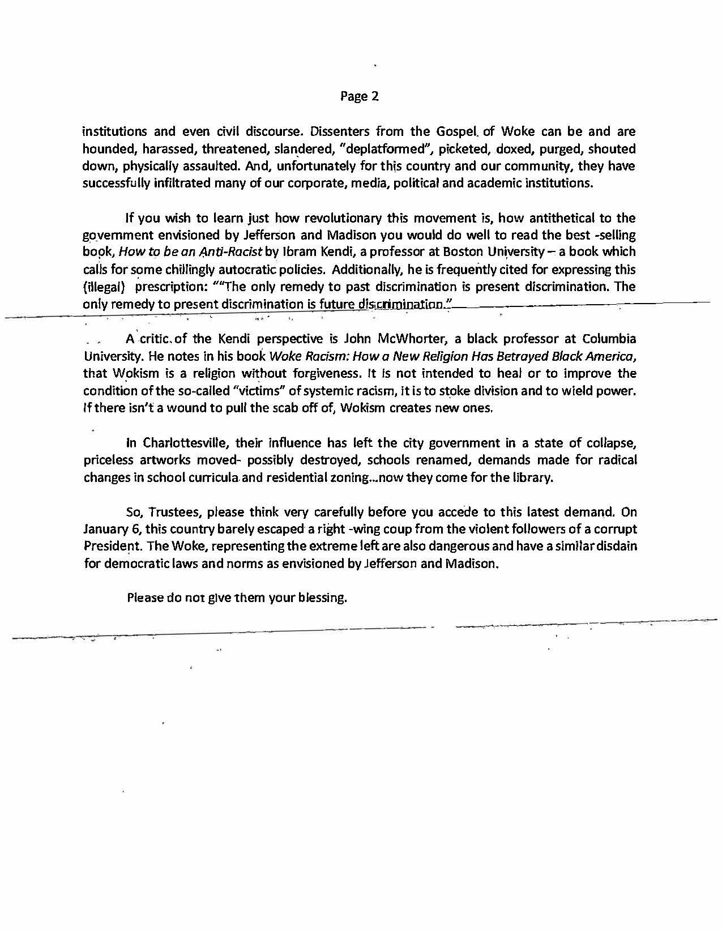
CHARLOTTESVILLE VIA USPS
--

- 6/21/22

message: This message is to the Library Board of Directors. I beg you to NOT change the name of our Library. Jefferson and Madison did so much good for our country even though they were flawed men with respect to slavery. Nevertheless, all humans are flawed in various ways. If members of the Board are perfect, non-flawed humans, then, by all means change the name. If not, be a bit circumspect.

VIA WEB CONTACT FORM

--

- 6/22/22

message: Dear Mr. Plunkett: Under separate email, I am sending you and your Committee some important background information on Thomas Jefferson's sale of his books in 1815 to the Library of Congress to reestablish the Library after its destruction by fire in the War of 1812... Aware that we are at a critical moment of seismic change in this country, and may I say worldwide, I think that the wiping out of important names of founders of our democracy, fragile as it is, and the elimination of teaching American History in our schools will leave our young people floundering and living on shifting sands without knowing the background of the people who took the risks to fight for freedom and establish the plans for a democracy... Do hope you and your Committee will consider this concern and not continue to 'wipe-out' history here in Virginia, birthplace of our nation.

https://www.monticello.org/site/research-and-collections/sale-books-library-congress-1815

Sale of Books to the Library of Congress (1815)
Thomas Jefferson was instrumental in rebuilding the Library of Congress when he sold the bulk of his book collection to the United States government in 1815.

During the War of 1812, British forces entered Washington, D.C., burning the Capitol building and the 3,000-volume library inside it. Writing to Samuel Harrison Smith in September 1814, Jefferson expressed his particular distress at this loss: "I learn from the newspapers that the vandalism of our enemy has triumphed at Washington over science as well as the arts, by the destruction of the public library with the noble edifice in which it was deposited."1 Recognizing that it would be difficult for Congress to replace the library that had been lost, given the war and the difficulty of procuring items from Europe, Thomas Jefferson offered up his large personal library to Congress.

In his letter to Smith, Jefferson indicated that he had intended that his library should eventually become public property and be offered at his death to Congress at whatever price was acceptable. But with the congressional library's destruction, Jefferson felt that it was the proper time to offer his library to Congress, "without regard to the small remnant of time, and the barren use of my enjoying it."2 He agreed to accept any valuation and payment terms Congress decided on (even payment after the war had ended), but insisted if Congress agreed to purchase his library, it should be purchased in its entirety.

Podcast: Jefferson and the Library of Congress »
Throughout his lifetime, Thomas Jefferson acquired thousands of books for his own personal collection. The majority of his books, however, would not stay by his side forever. In this episode of Mountaintop History, Monticello Guide Kyle Chattleton shares the story of how Jefferson's collection helped restart the Library of Congress.

Jefferson's offer was met by warm support from many in the House and Senate; still, the bill introduced to authorize the purchase of Jefferson's library faced congressional opposition, particularly from the Federalists, such as Cyrus King, who argued that Jefferson's books would help disseminate his "infidel philosophy" and were "good, bad, and indifferent ... in languages which many can not read, and most ought not."3 The bill finally passed with a narrow margin along party lines.4

Georgetown bookseller Joseph Milligan, who had been engaged to count the number of books by size in Jefferson's book catalogue, determined that the library had a total of 6,487 volumes. The terms of the sale were thus fixed at $23,950 for the 6,487 volumes, with deductions to be made if the actual count was less than the number of books recorded in Jefferson's catalogue. When Jefferson later completed his own physical count of the number of volumes he had in his possession, he found that he had 6,707, or 220 more than had been reported to Congress; he had inadvertently omitted recording some volumes in his catalogue, and others were missing. He did not think it was right to retain the surplus books, nor did he ask for the extra $1,172.50 due to him from Congress. Jefferson did utilize the proceeds of the sale to settle some debts. Of the $23,950, Jefferson arranged to remit $10,500 to settle his debts with William Short, and $4,870 to settle his debts with John Barnes of Georgetown.

Jefferson received news of the finalized sale in February 1815.5 The books were shipped starting in mid-April in the bookcases that they already occupied;6 they were transported in ten wagons to Washington, and arrived by the middle of May. On May 8, 1815, as the last wagon-load of books left Monticello, Jefferson remarked in a letter to Samuel Harrison Smith, who had been instrumental in the sale, "an interesting treasure is added to ... [Washington, D.C.], now become the depository of unquestionably the choicest collection of books in the US. and I hope it will not be without some general effect on the literature of our country."7

Further Sources
- Library of Congress. A Century of Lawmaking for the New Nation. Contains records of bills and debates relating to the purchase of Jefferson's library.
- Library of Congress. Jefferson's Library. The online companion to an exhibit at the Library of Congress on Jefferson's library.
- Malone, Dumas. Thomas Jefferson and the Library of Congress. Washington D.C.: Library of Congress, 1977.
- Pitch, Anthony. The Burning of Washington: The British Invasion of 1814. Annapolis, Md.: Naval Institute Press, 1998.
- Sowerby.
- Tay, Endrina. "'Unquestionably the Choicest Collection of Books in the U.S.': The 1815 Sale of Thomas Jefferson's Library to the Nation." Common-Place: The Journal of Early American Life 16, no. 4 (2016).
- Wilson, Douglas. Jefferson's Books. Charlottesville: Thomas Jefferson Memorial Foundation, 1996.
- <a class="external text" data-cke-saved-href="https://tjportal.on.worldcat.org/search?q=Jefferson+library+of+congress&... href="//www.monticello.org/%3Ca%20href%3D"https://tjportal.on.worldcat.org/search?q=Jefferson+library+of+congress&qt=results_page&dblist=638&scope=0&oldscope=0&fq="">https://tjportal.on.worldcat.org/search?q=Jefferson+library+of+congress&... rel="nofollow" target="_blank" "="">Look for further sources in the Thomas Jefferson Portal.
- 1. Jefferson to Smith, September 21, 1814, in PTJ:RS, 7:681. Transcription available at Founders Online.
- 2. Ibid., 7:682.
- 3. Quoted in William Dawson Johnston, History of the Library of Congress (Washington, D.C.: Government Printing Office, 1904), 1:86.
- 4. The bills for the purchase of Jefferson's books passed in the Senate on December 3, 1814, and in the House on January 30, 1815. See "Editorial Note," in PTJ:RS, 7:679-81. Text available at Founders Online.
- 5. Smith to Jefferson, February 15, 1815, in PTJ:RS, 8:270. Transcription available at Founders Online.
- 6. See Jefferson's "Observations on the Transportation of the Monticello Library," [ca. February 27, 1815], in PTJ:RS, 8:289-91. Transcription available at Founders Online.
- 7. Jefferson to Smith, May 8, 1815, in PTJ:RS, 8:476. Transcription available at Founders Online.

VIA WEB CONTACT FORM AND EMAIL

--

- 6/22/22

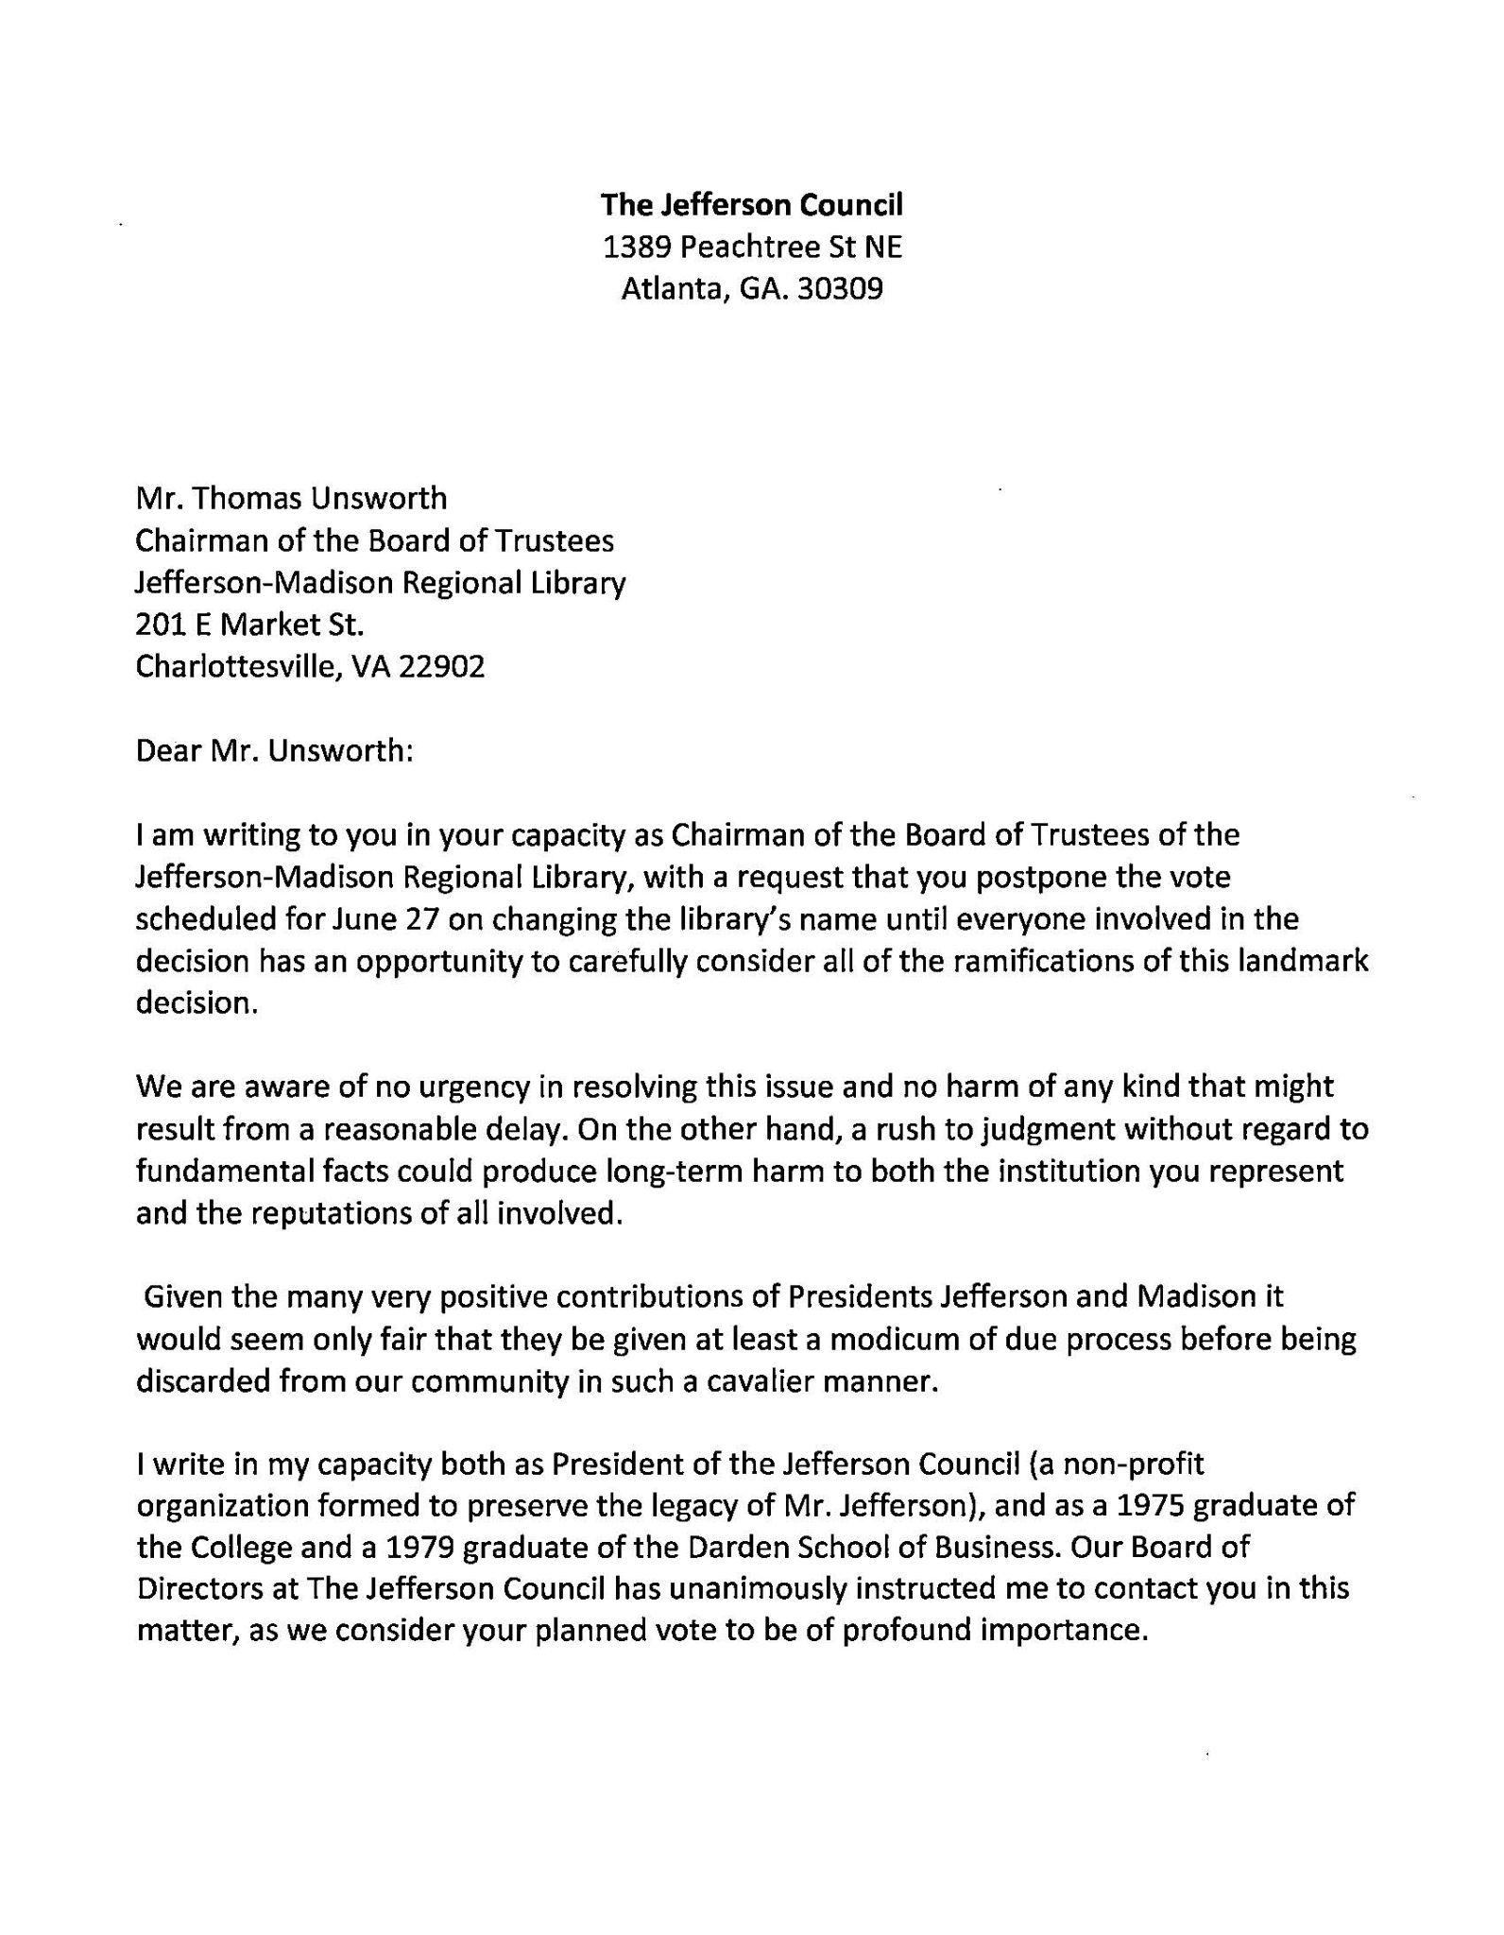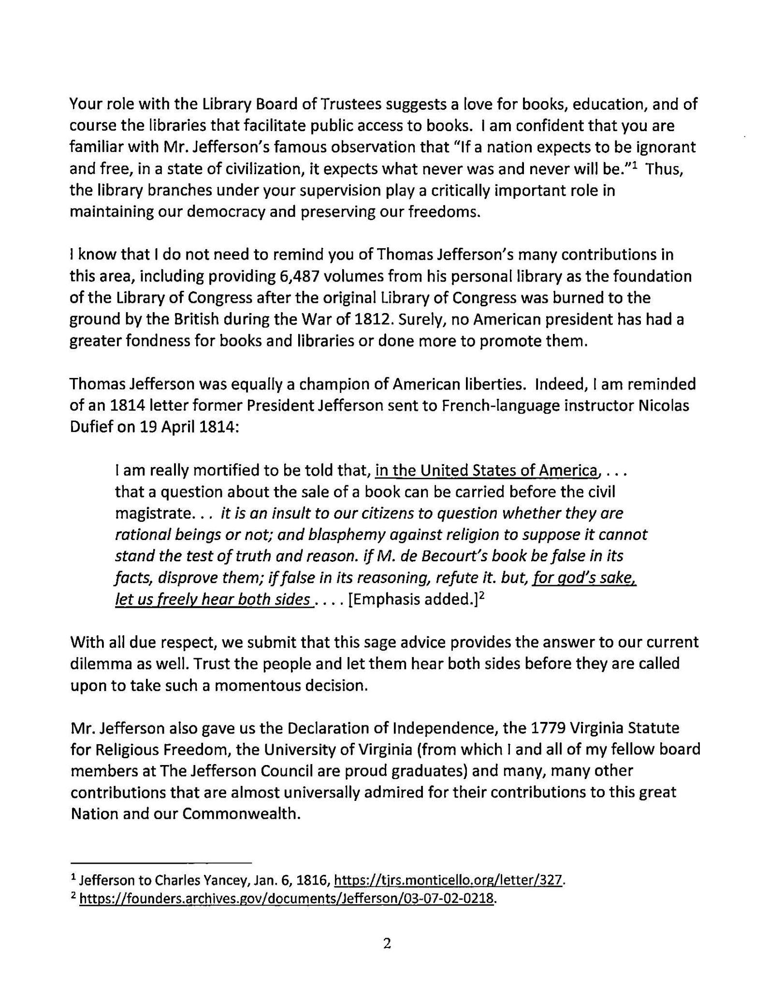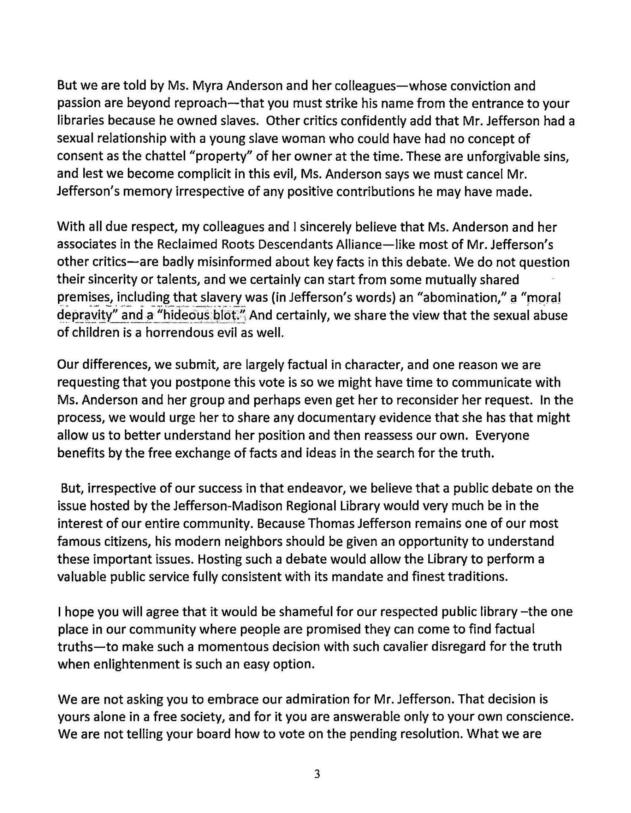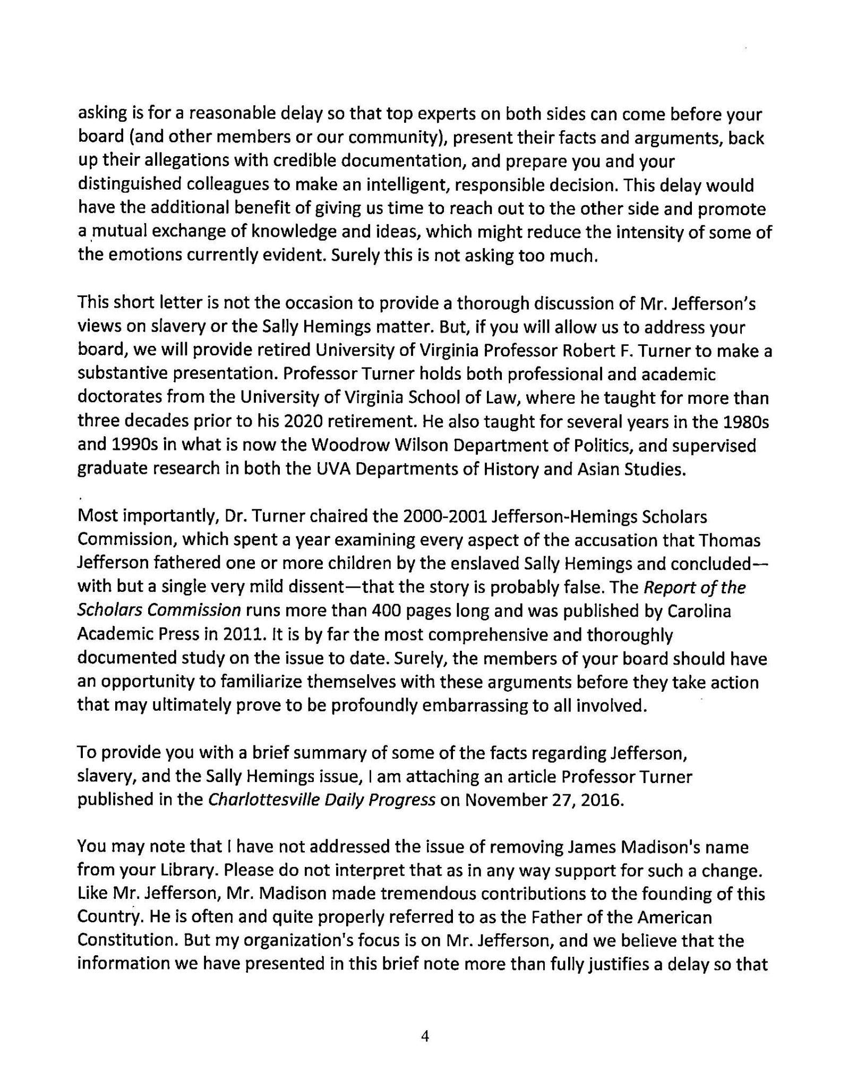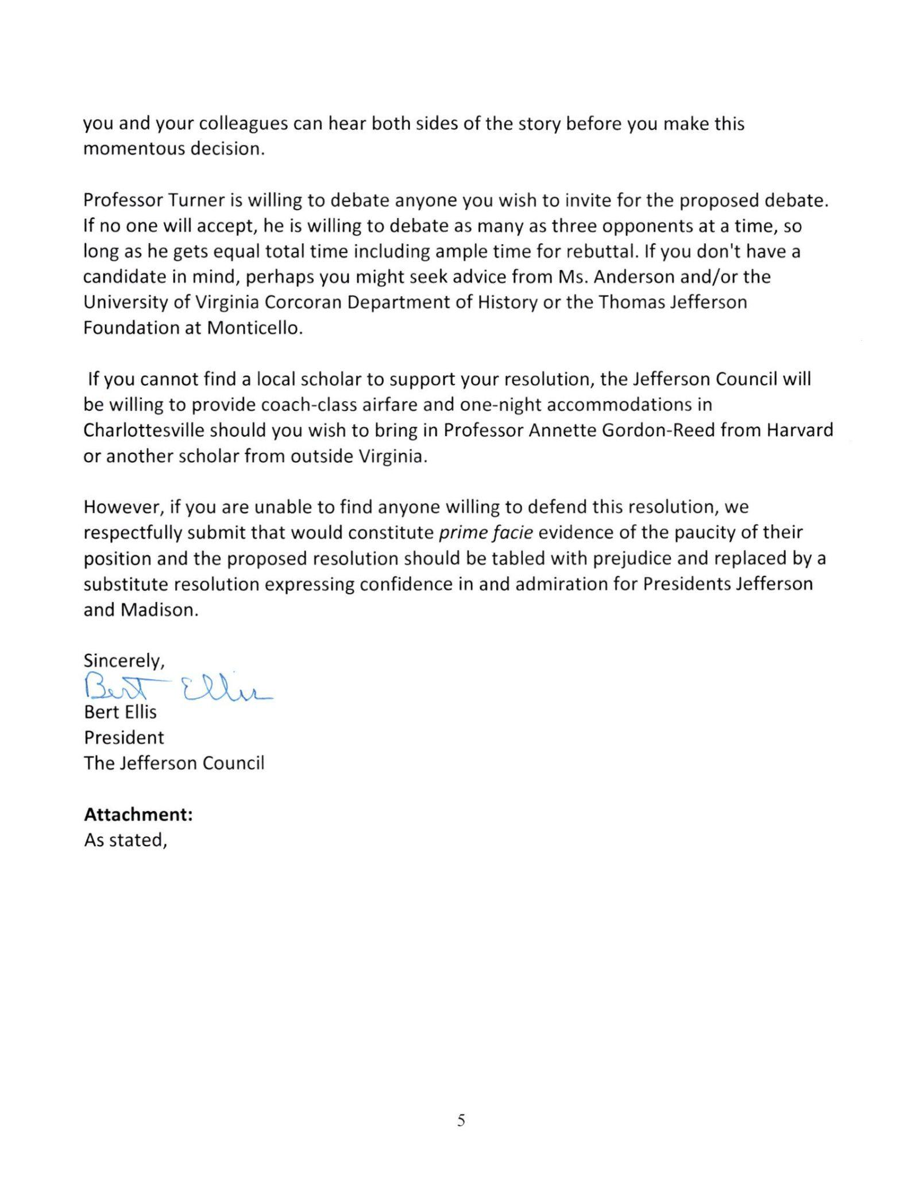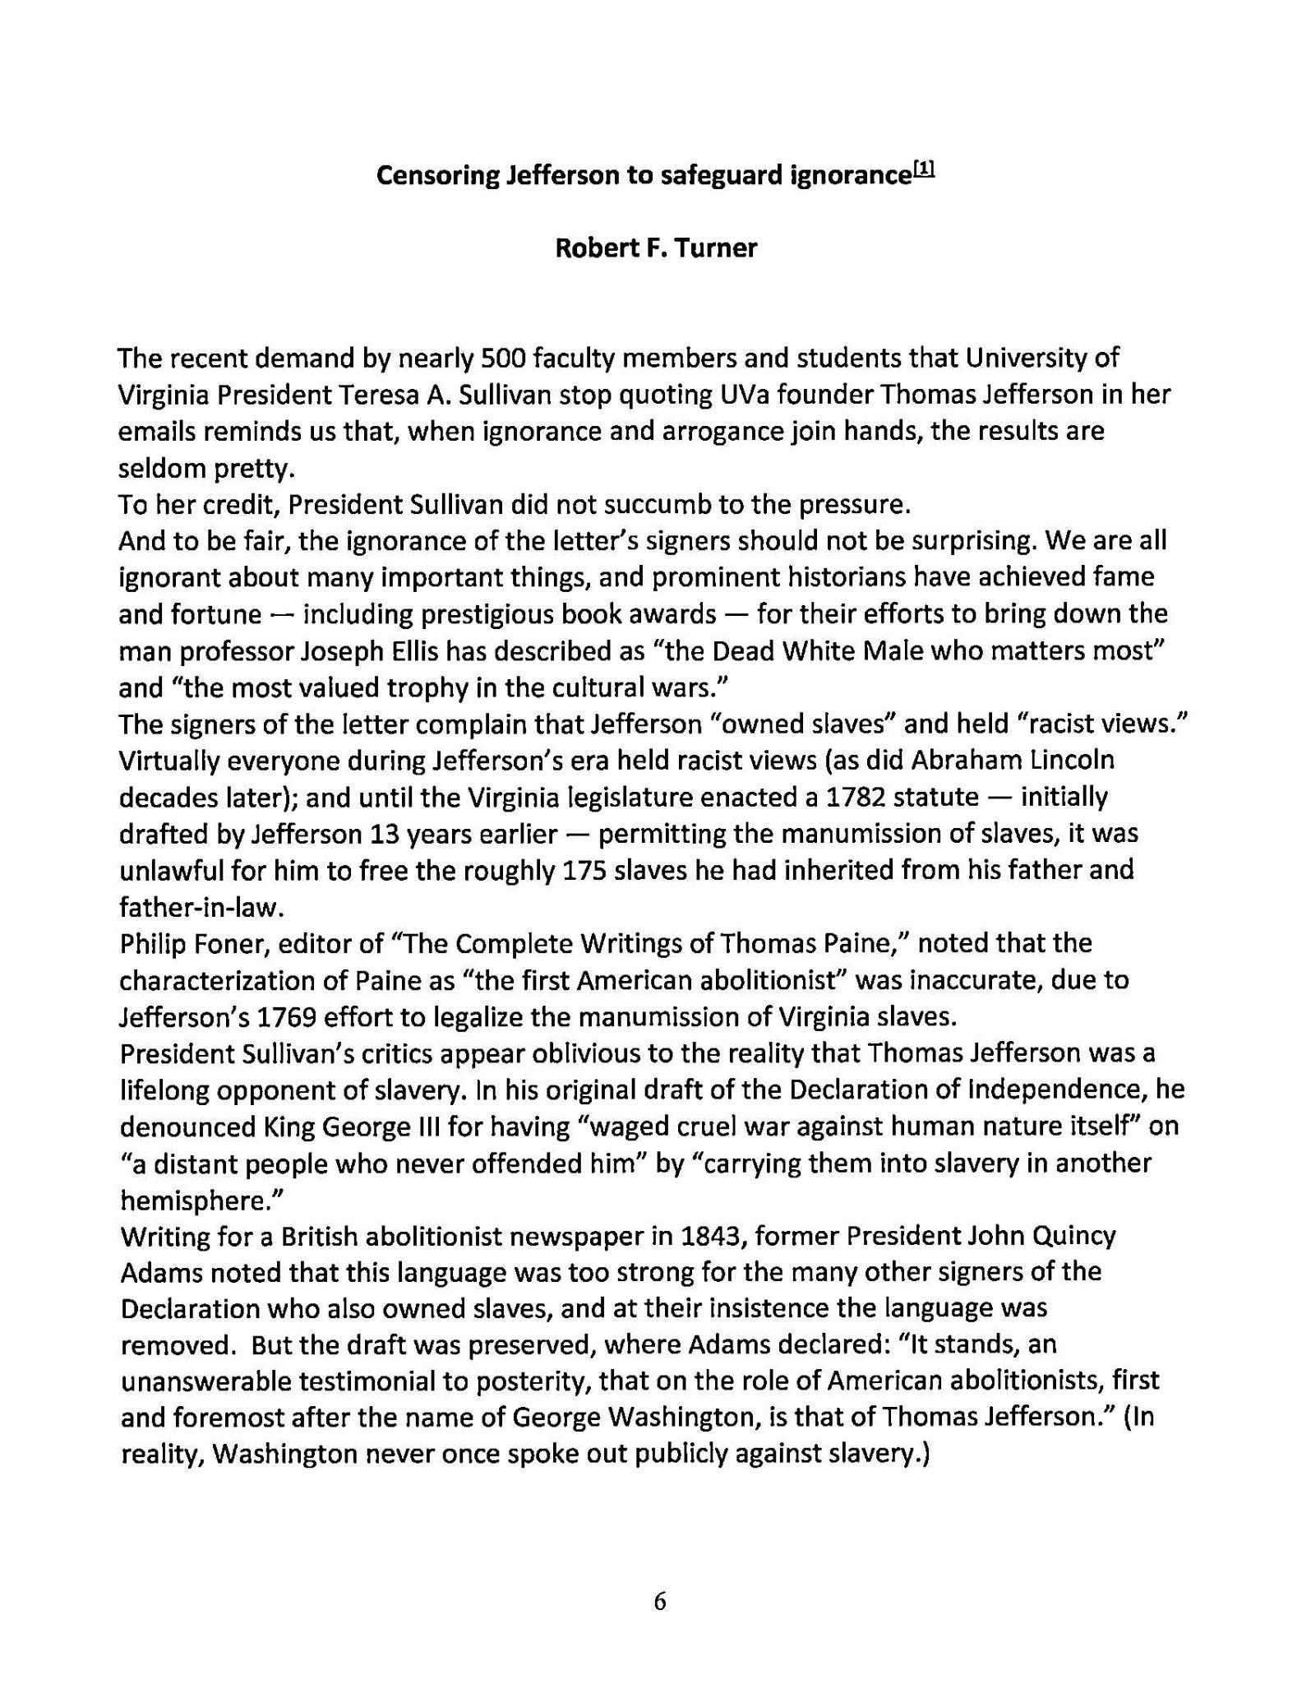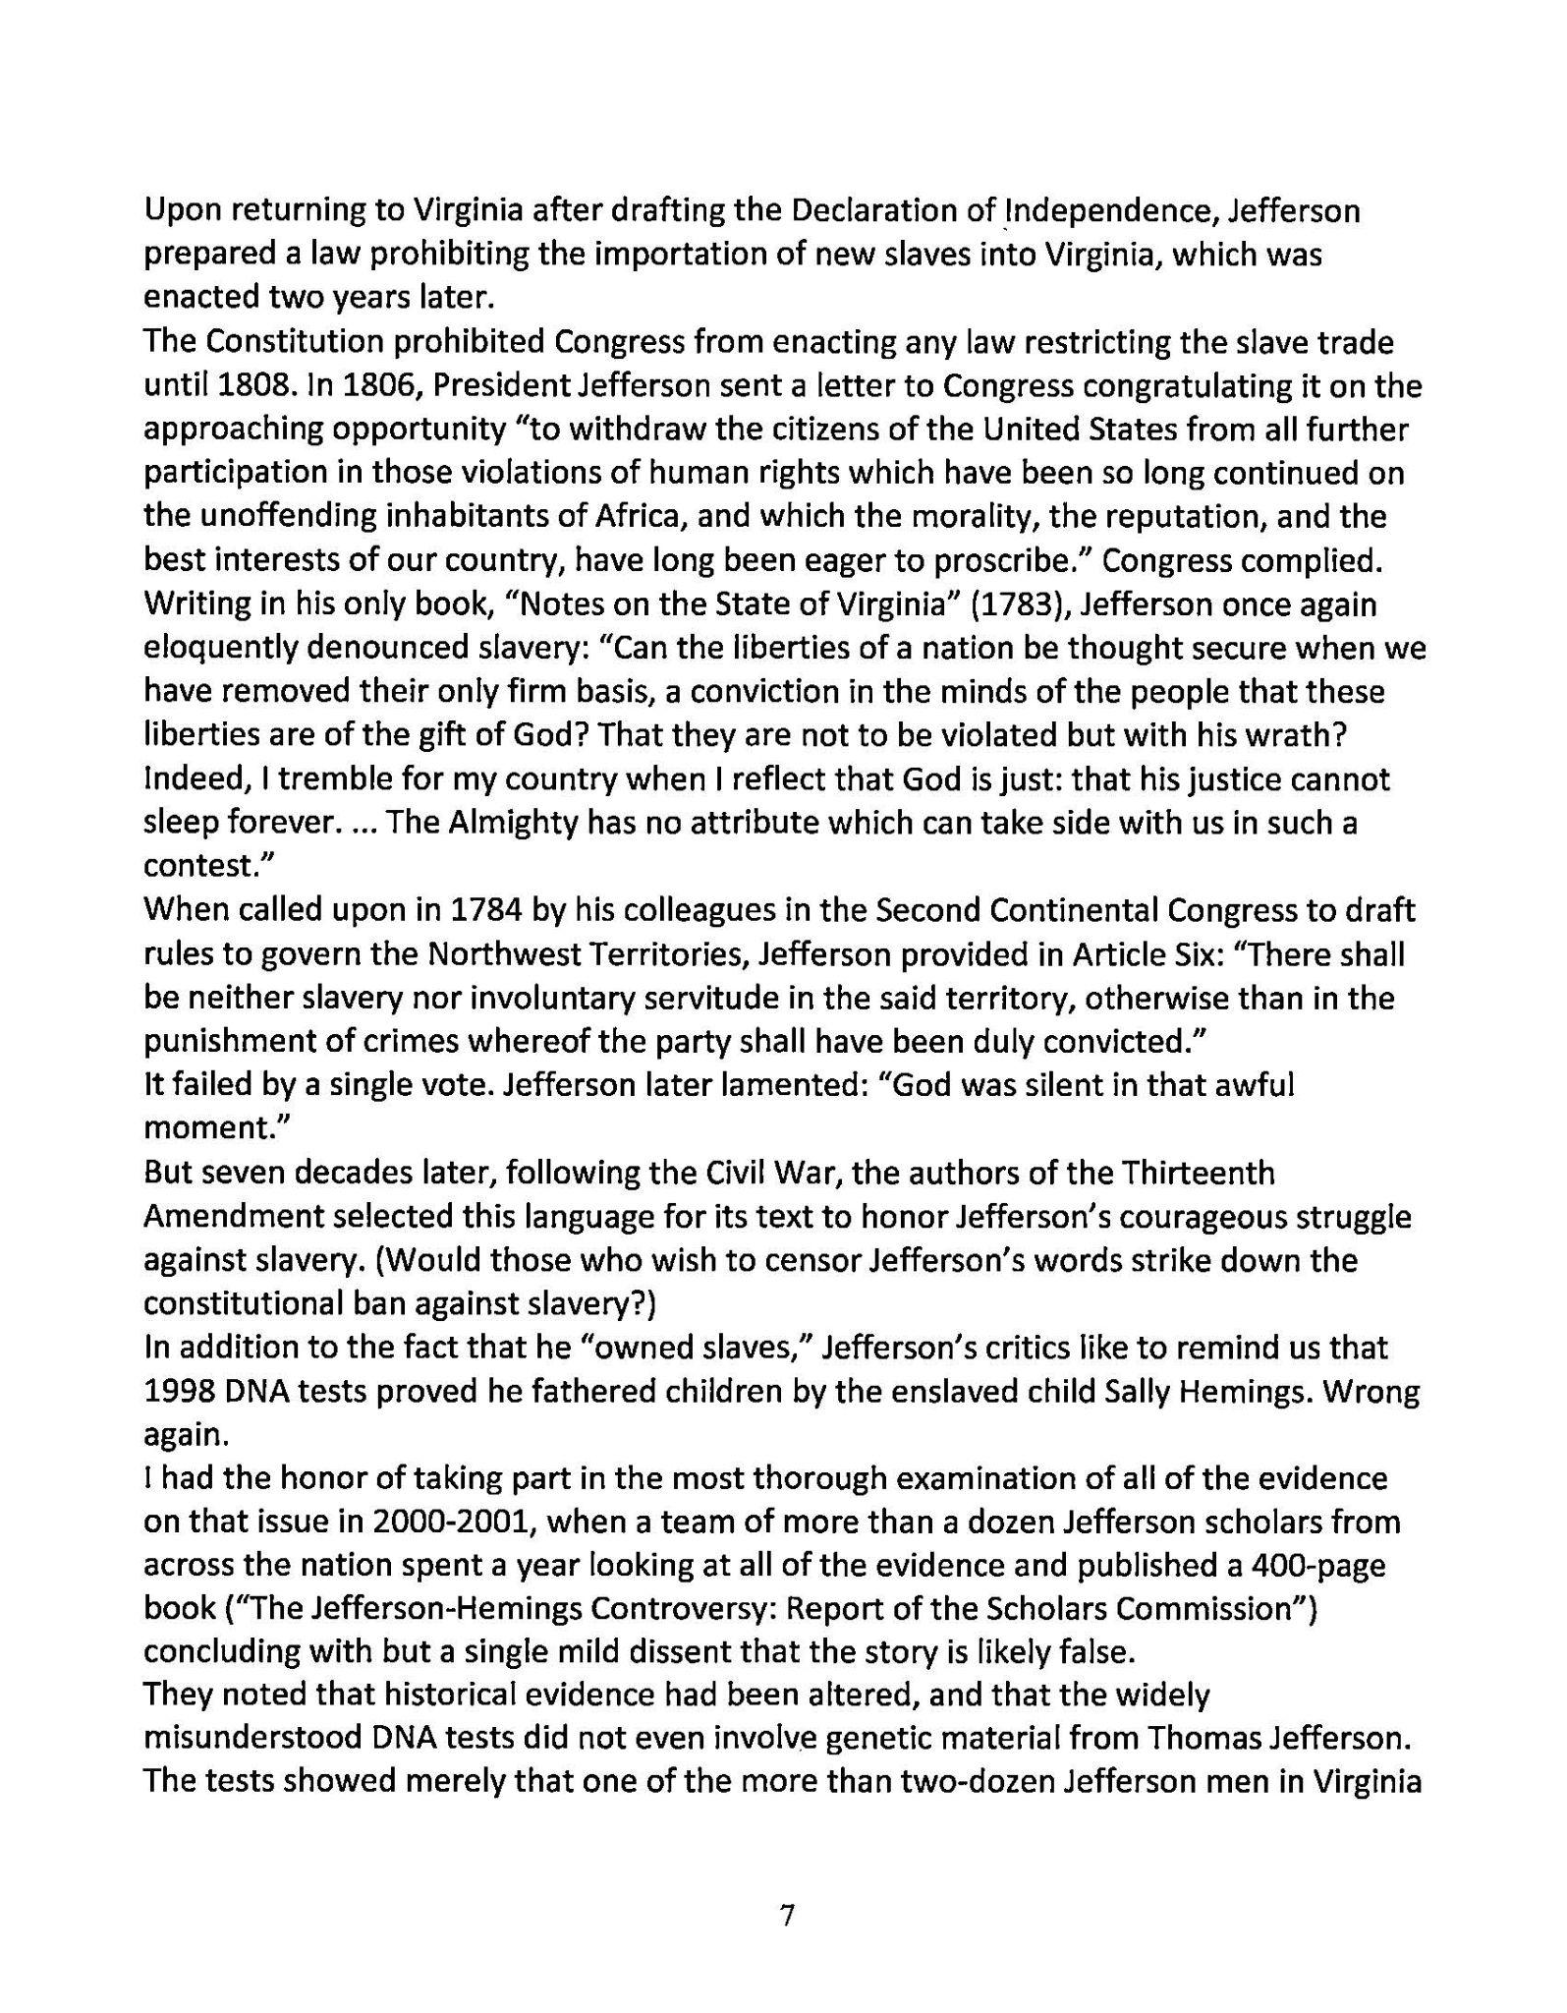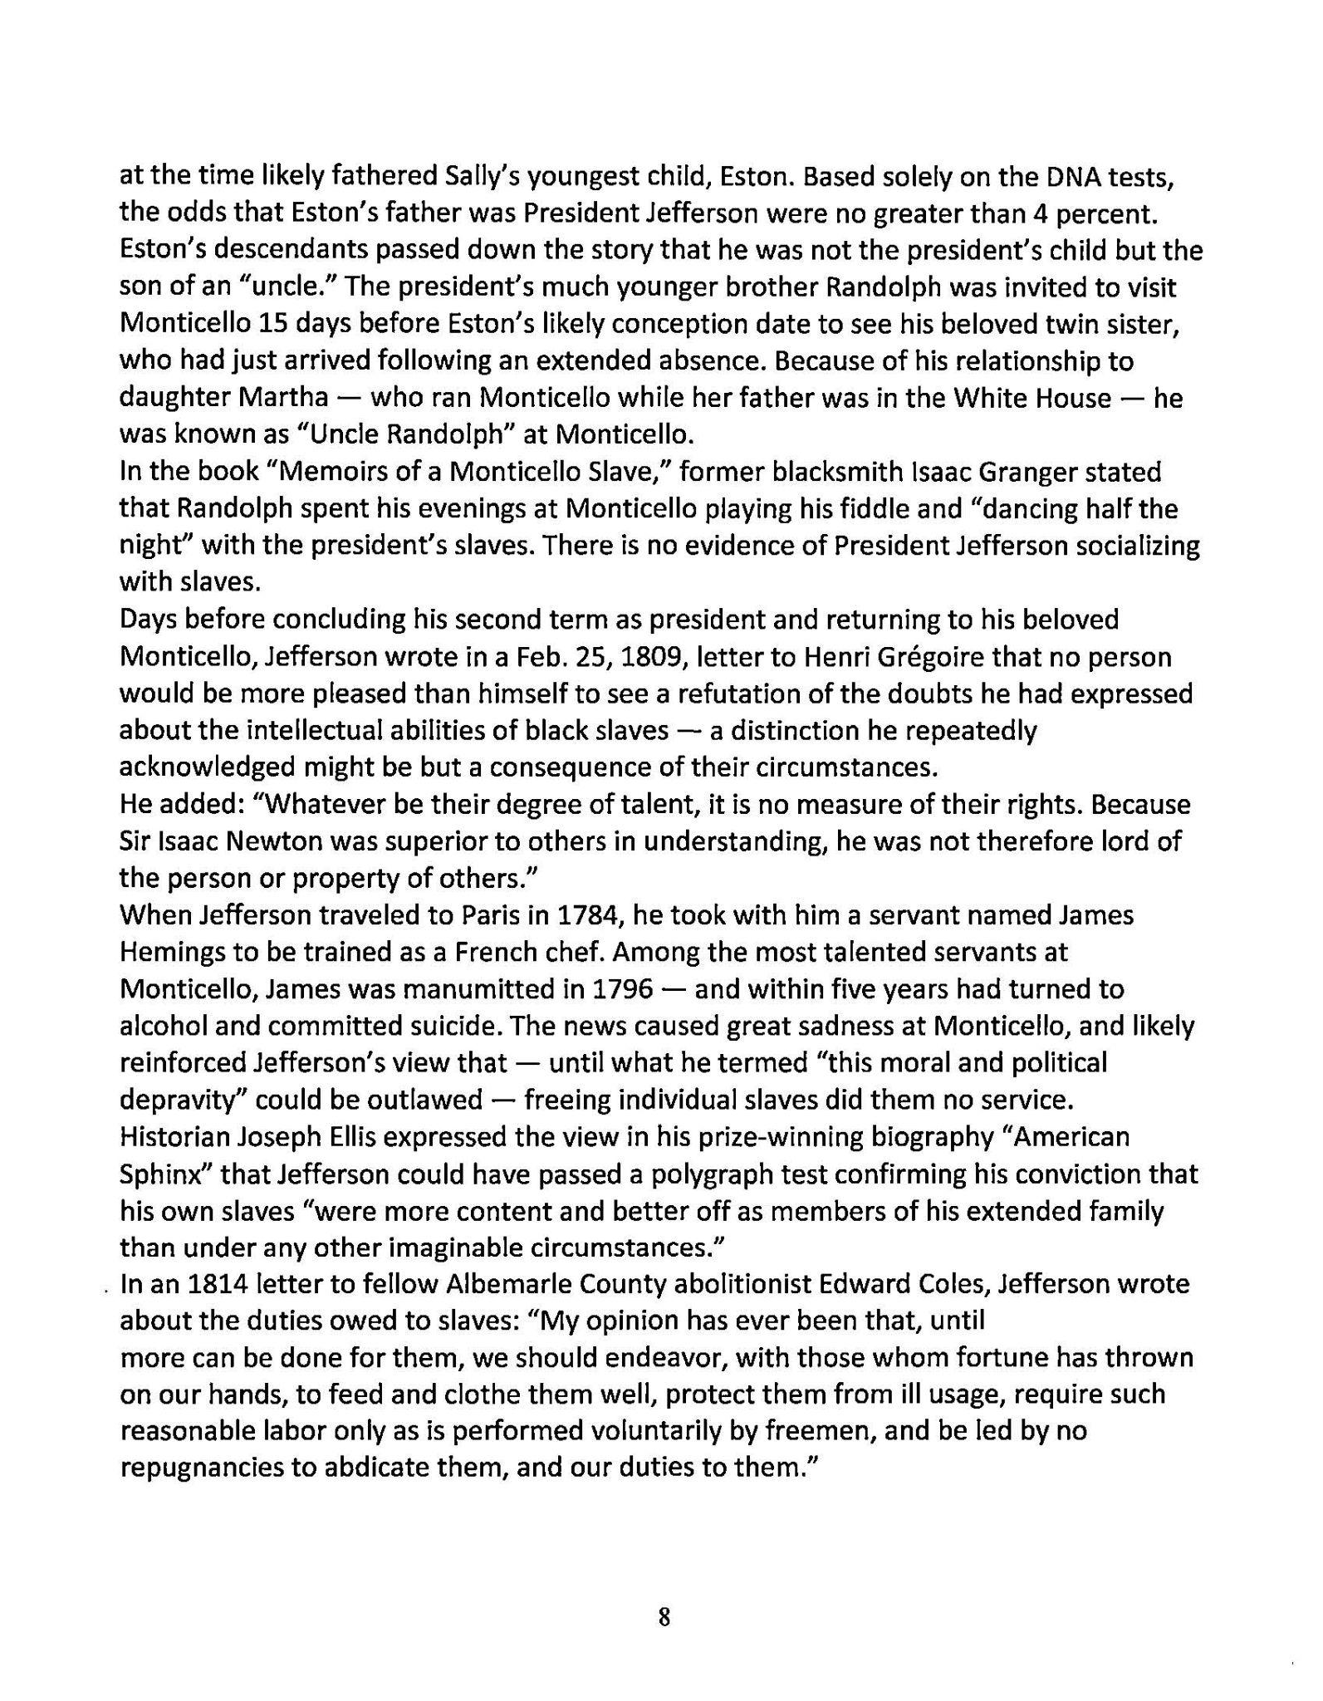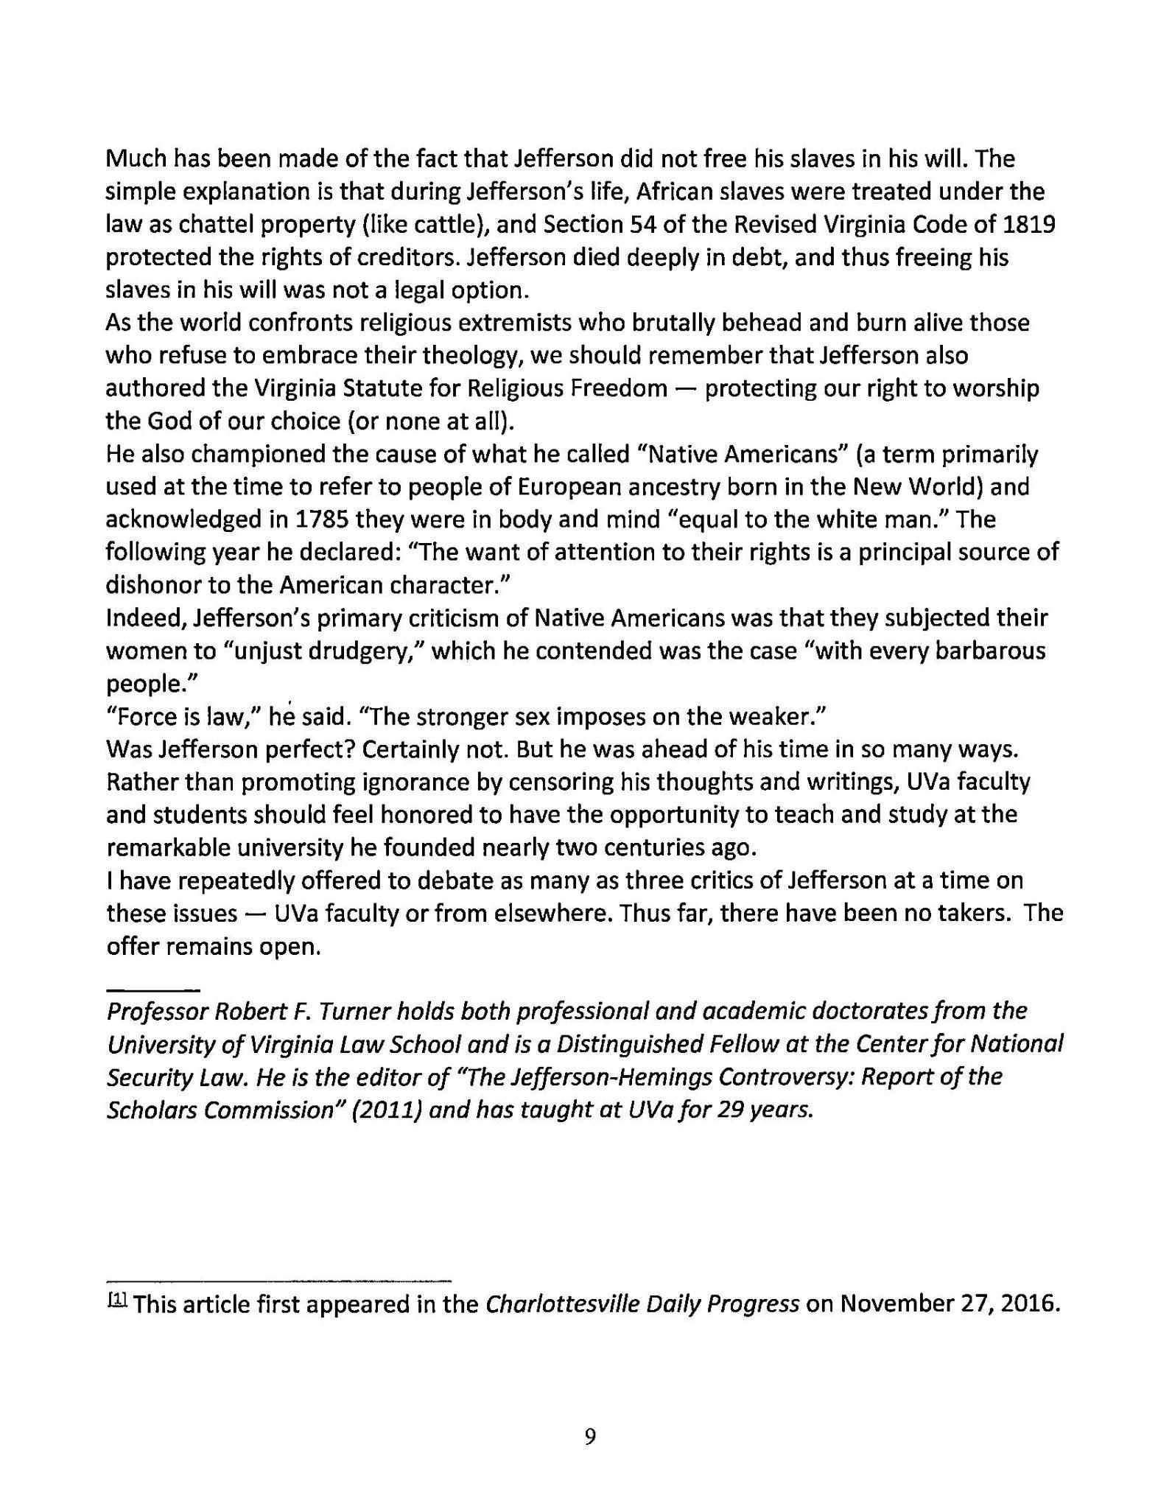
VIA USPS

--

